Lesson 4
Objective: Add fractions with sums between 1 and 2.
Math Minute: Please plan up to 10 minutes for students to connect to the lesson by implementing the steps below.
- Gather Information: Form 1-2 general questions that can lead students to offer information about the following:
  - Home or personal experiences regarding the math content
    - Ask students to share how they can use the numbers in something they use or have seen guardians use at home.
    - Connect the math content to an experience that occurred outside of school.
  - Previous experience with the math content
    - Allow students to share what they remember.
    - How they were successful or need more support?
- Make Connections
  - Use the information from students to provide examples on how the content presented in the current lesson relates to the examples that students shared.
- Adjust Practice
  - Plan to include the student’s experience in one or more of the problems during independent practice.
  - Alter one or more problems in the concept development or Exit Ticket that directly connects the information in the discussion.

Informing Instruction: Use the information below to respond to students if students need support during the lesson or independent practice.
Below are some questions to support teachers in altering instruction if necessary.
- How can I use this information to plan for possible misconceptions?
- What is a scaffold to support students that are struggling?
- What are quick fixes I can implement during the lesson to set students up for success?
- Analyze the standard, exit ticket, and the objective.
    - What is mastery?
    - What specific skills relate to students being able to show mastery?
    - What skill did students need from previous grades?

Suggested Lesson Structure
 Fluency Practice (8 minutes)
 Application Problems (7 minutes)
 Concept Development (35 minutes)
 Student Debrief (10 minutes)
Total Time (60 minutes)
Fluency Practice (8 minutes)
- Adding Fractions to Make One Whole 4.NF.3a (4 minutes)
- Skip-Counting by $\frac{1}{3}$ Yard 5.MD.1 (4 minutes)
Adding Fractions to Make One Whole (4 minutes)
Note: This fluency activity is a quick mental exercise of part–part–whole understanding as it relates to fractions.
T: I will name a fraction. You say a fraction with the same denominator so that together our fractions add up to 1 whole. For example, if I say 1 third, you say 2 thirds. $\frac{1}{3}+\frac{2}{3}=\frac{3}{3}$ or 1 whole. Say your answer at the signal.

 | NOTES ON  MULTIPLE MEANS  OF ENGAGEMENT:
Depending on the group of students, consider supporting them visually by making fraction cards that show circles divided into fourths, fifths, tenths, etc. Flash the corresponding card while naming the fraction. English language learners will have a visual support to accompany language, and students working below grade level can see how many more to make one whole.

T: 1 fourth? (Signal.)
S: 3 fourths.
T: 1 fifth? (Signal.)
S: 4 fifths.
T: 2 tenths? (Signal.)
S: 8 tenths.
Continue with the following possible sequence:
$\frac{\text{1}}{\text{3}}\text{, }\frac{\text{3}}{\text{5}}\text{, }\frac{\text{1}}{\text{2}}\text{, }\frac{\text{5}}{\text{10}}\text{, }\frac{\text{6}}{\text{7}}\text{, and }\frac{\text{3}}{\text{8}}\text{ .}$

Skip-Counting by $\frac{1}{3}$Yard (4 minutes)
Note: This skip-counting fluency activity prepares students for success with addition and subtraction of fractions between 1 and 2.
T: Let’s count by $\frac{1}{3}$ yard. (Rhythmically point up until a change is desired. Show a closed hand and then point down. Continue, mixing it up.)

NOTES ON
MULTIPLE MEANS
OF ENGAGEMENT:
Periodically challenge students working above grade level to rename each fraction of a yard as a number of feet.

S: $\frac{1}{3}$ yard, $\frac{2}{3}$ yard, 1 yard (stop), $\frac{2}{3}$ yard (stop), 1 yard, 1 $\frac{1}{3}$ yards, 1 $\frac{2}{3}$ yards, 2 yards (stop), 1 $\frac{2}{3}$ yards, 1 $\frac{1}{3}$ yards, 1 yard (stop).
Continue sequence going up to and beyond 3 yards, paying careful attention when crossing over whole number units.
Application Problem (7 minutes)
Leslie has 1 liter of milk in her fridge to drink today. She drank $\frac{1}{2}$ liter of milk for breakfast and $\frac{2}{5}$ liter of milk for dinner. How much of a liter did Leslie drink during breakfast and dinner?
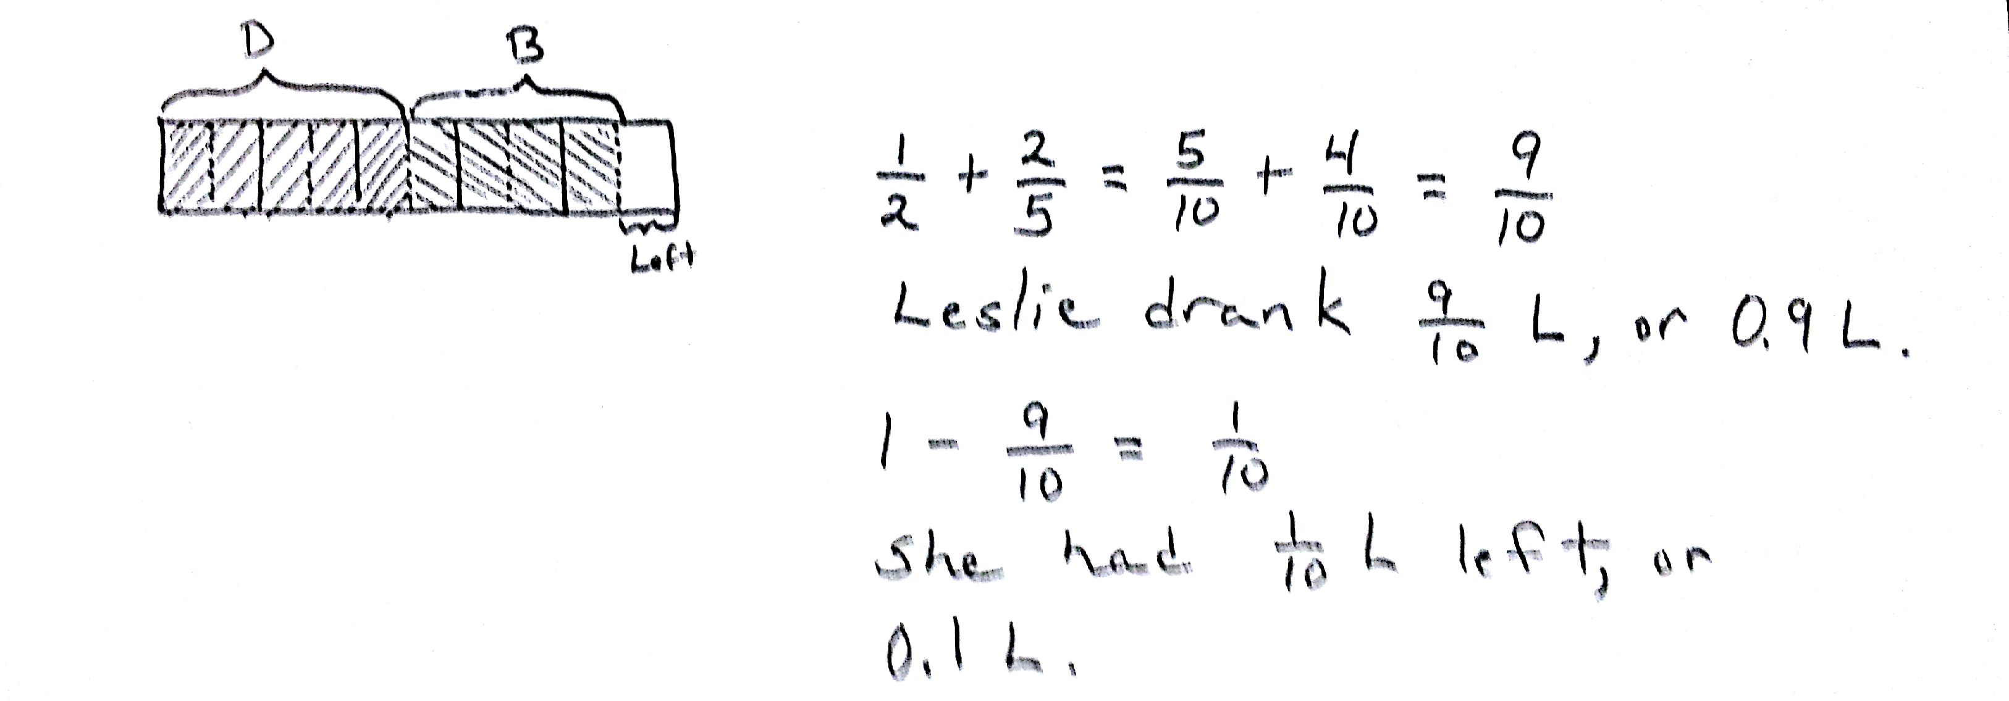

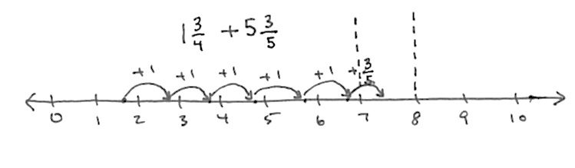
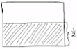
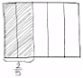
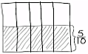
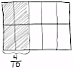
(Extension: How much of a liter of milk does Leslie have left to drink with her dessert? Give your answer as a fraction of liters and as a decimal.)

NOTES ON
MULTIPLE MEANS
OF ACTION AND EXPRESSION:
It can be helpful to English language learners to have others model speech to describe the models they draw. If appropriate, select an English language learner to help make the drawing for the class.

T: Let’s read the problem together.
S: (Read chorally.)
T: What is our whole?
S: 1 liter.
T: Tell your partner how you might solve this problem.
S: (Discuss.)

T: (Select a student to draw a model for this problem.) I see that Joe has a great model to help us solve this problem. Joe, please draw your picture for us on the board.
S: (Draw.)
T: Thank you, Joe. Let’s say an addition expression that represents this word problem.
S: 2 fifths plus 1 half.
T: Why can’t we add these two fractions?
S: They are different. They have different denominators. The units are different. We must find a like unit between fifths and halves. We can use equal fractions to add them. The fractions will look different, but they will still be the same amount.
T: Joe found like units from his drawing. How many units are inside his rectangle?
S: 10.
T: That means we will use 10 as our denominator, or our named unit, to solve this problem. Say your addition sentence now using tenths.
S: 4 tenths plus 5 tenths equals 9 tenths.
T: Good. Please say a sentence about how much milk Leslie drank for breakfast and dinner to your partner.
S: Leslie drank $\frac{9}{10}$ liter of milk for breakfast and dinner.
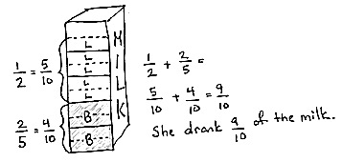
T: With words, how would you write 9 tenths as a decimal?
S: Zero point nine.
T: Now, we need to solve the extension question. How much milk will Leslie have available for dessert? Tell your partner how you solved this.
S: I know Leslie drank $\frac{9}{10}$ liter of milk so far. I know she has 1 whole liter, which is 10 tenths. 9 tenths plus 1 tenth equals 10 tenths, so Leslie has 1 tenth liter of milk for her dessert.
Note: Students solve this Application Problem involving addition of fractions with unlike denominators, using visual models as learned in Lesson 3.

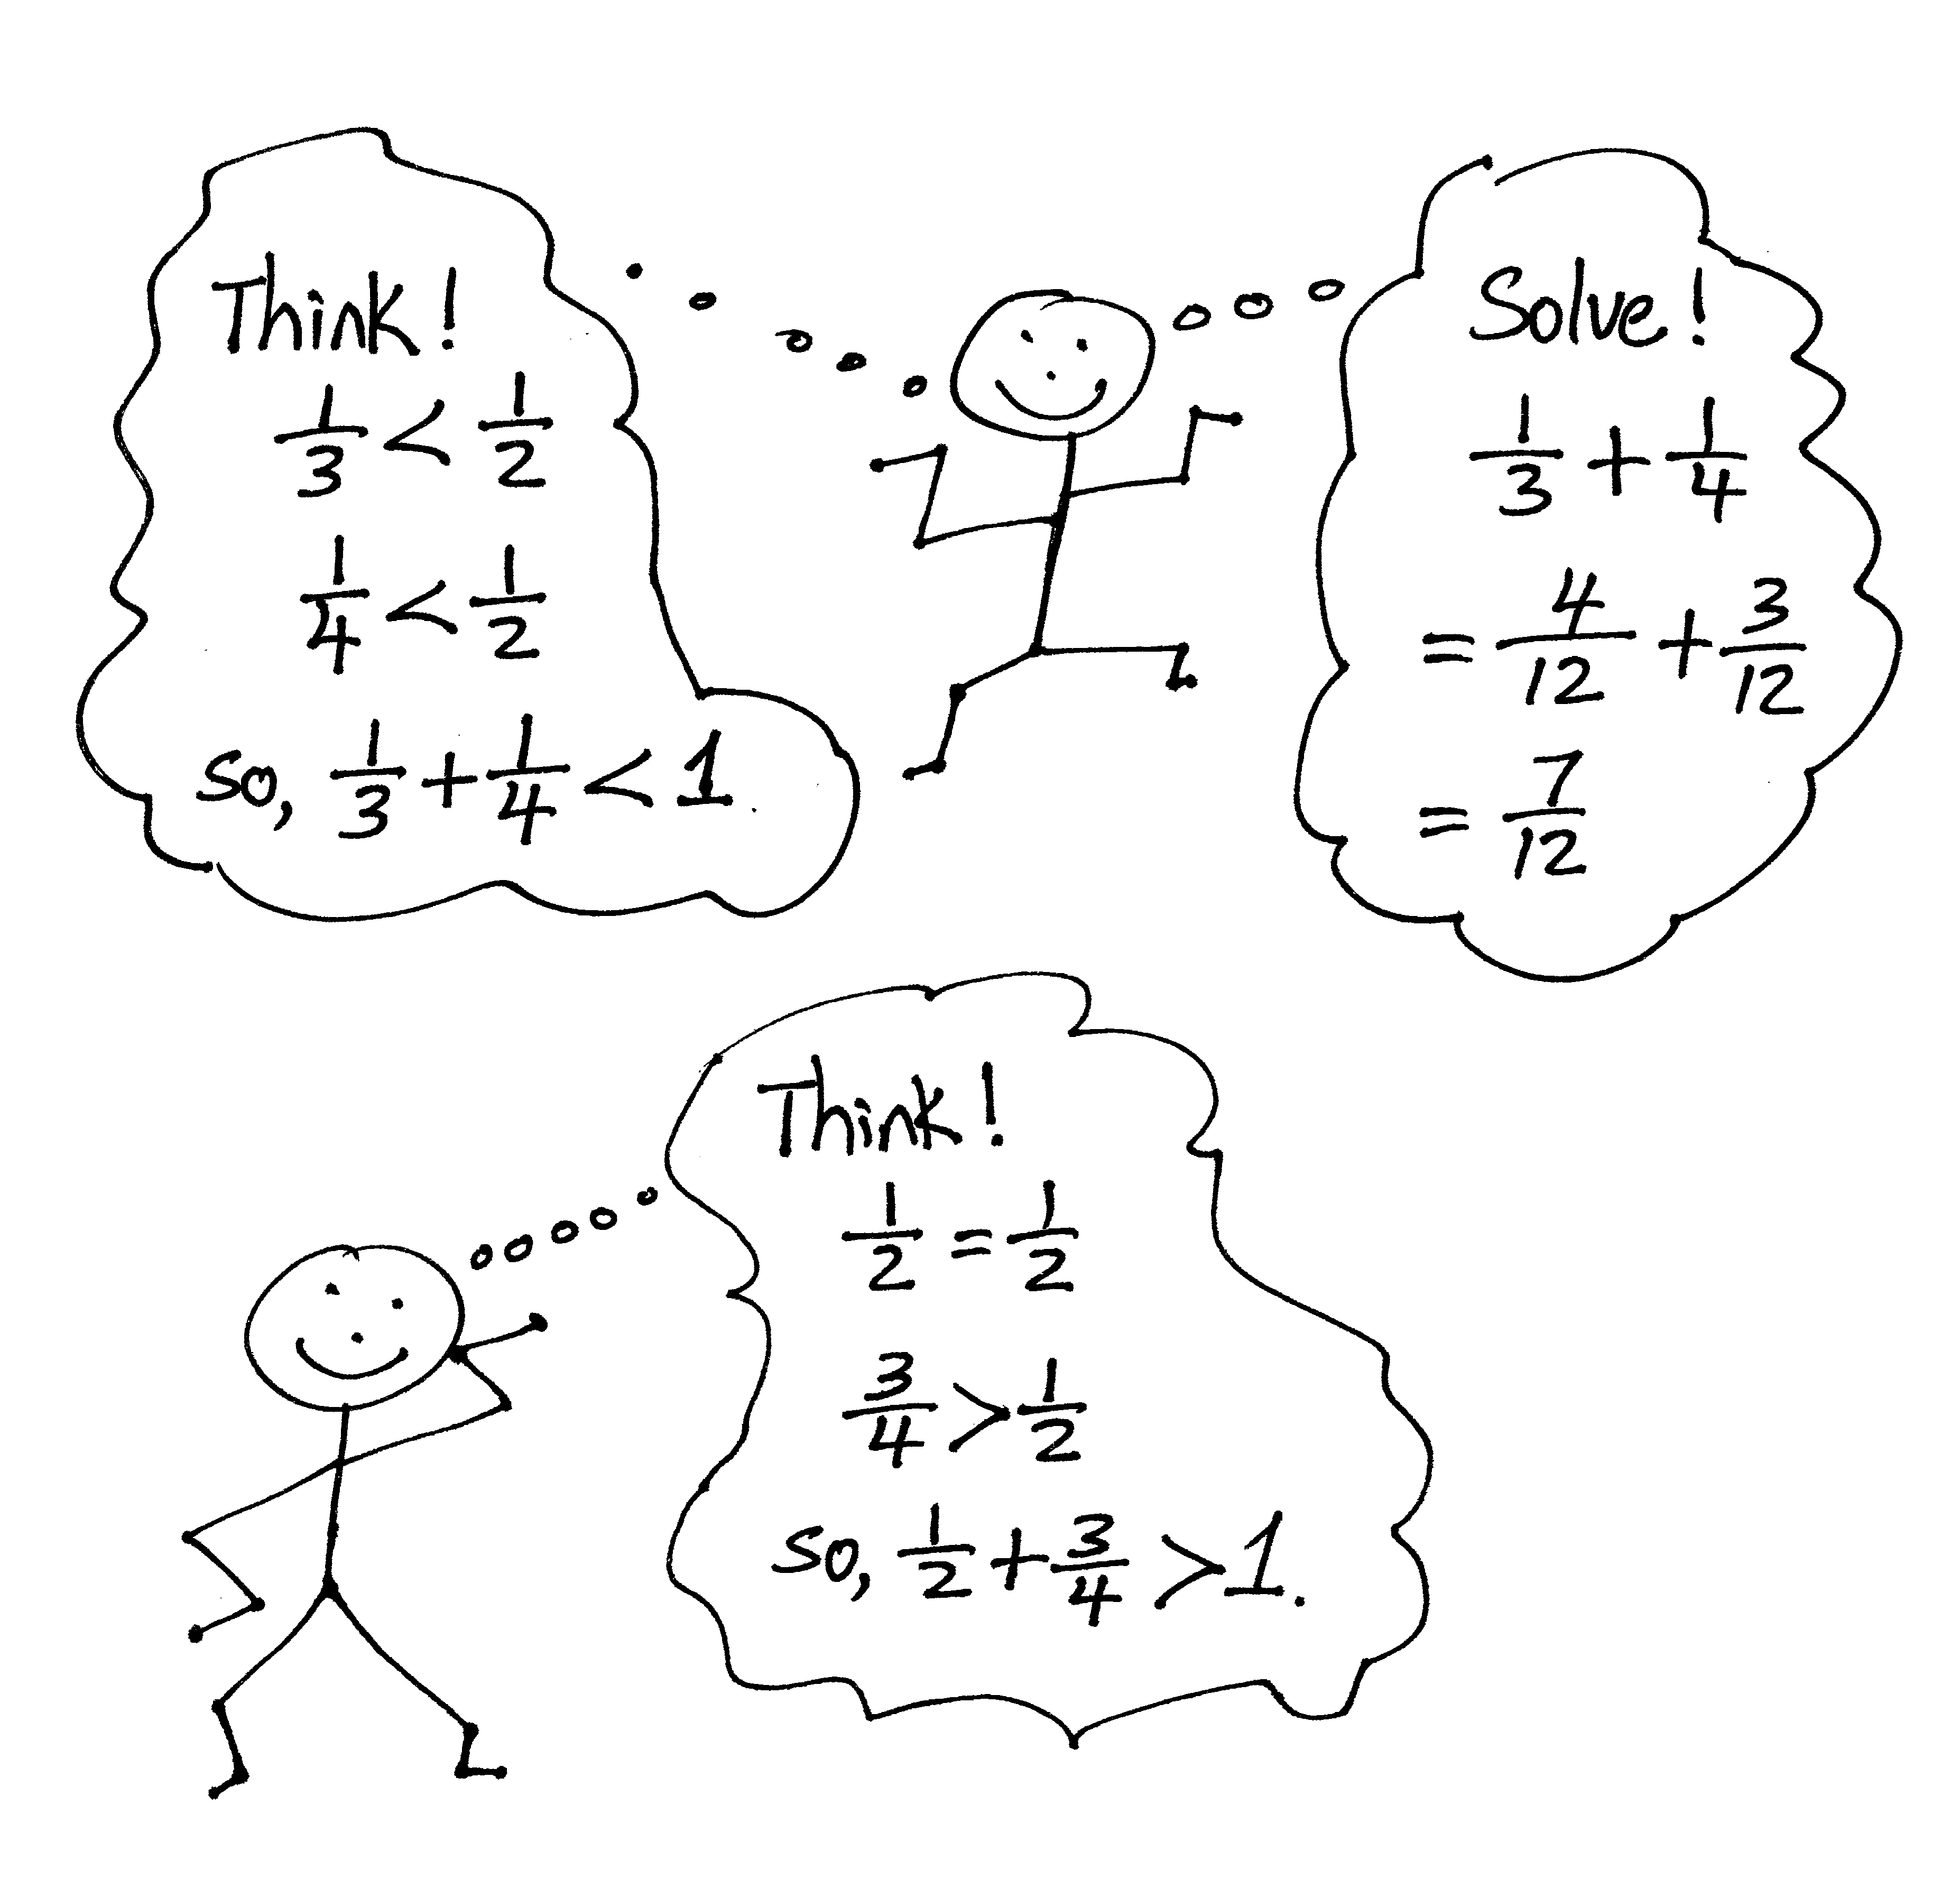
Concept Development (35 minutes)
Materials: (S) Personal white board
Gather Information:
Question: What is something that you can use at home to describe fractions?
S: Cooking, how to cut or split something
If students are struggling answering the question, push them to think about things they’ve had to split or distribute amongst their families or friends? Ask how many friends?
S: A cake
Describe the relation to the math content: If you have 3 friends and one cake. You would give each friend a third of the cake. Use this to transition to Problem 1a: “If you have a slice that is 1/3 of a cake, and a friend has a slice that is 1/4 of the same cake, how much cake do you two have altogether?”
Problem 1: a. $\frac{1}{3}+\frac{1}{4}$ b. $\frac{1}{2}+\frac{3}{4}$
T: (Write Problem 1(a) on the board.) When you see this problem, can you estimate the answer? Will it be more or less than 1? Talk with your partner.
S: The answer is less than 1 because $\frac{1}{3}$ and $\frac{1}{4}$ are both less than $\frac{1}{2}$ . So, if two fractions that are each less than $\frac{1}{2}$ are added together, they will add up to a fraction less than 1 whole.
T: (Write Problem 1(b) on the board.) Now, look at this problem. Estimate the answer.
S: (Discuss.)
T: I overheard Camden say the answer will be more than 1 whole. Can you explain why you think so?
S $\frac{3}{4}$ is more than 1 half and it’s added to 1 half; we will have a sum greater than 1 whole.
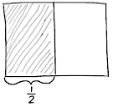
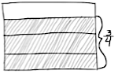
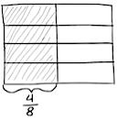
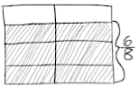
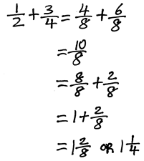
T: What stops us from simply adding?
S: The units are not the same.
T: (Draw two rectangular fraction models.) How many parts do I need to draw for 1 half?
S: 2.
T: (Partition one rectangle into 2 units.) How many parts should I shade and label to show 1 half?
S: 1.
T: Just like the previous lesson, we label our picture with $\frac{1}{2}$. Now, let’s partition this other rectangle horizontally. How many rows to show fourths?
S: 4.
T: How many rows do we shade to represent 3 fourths?
S: 3.
T: We bracket 3 fourths of this rectangle. Now, let's partition both wholes into units of the same size. How many parts do we need in each rectangle to make the units the same size?
S: 8.
T: (Partition the models.) What is the fractional value of one unit now?
S: 1 eighth.
T: Eighths is the like unit or common denominator. We can decompose $\frac{1}{2}$ into eighths. How many eighths are equal to 1 half? (Point to the 4 boxes bracketed by $\frac{1}{2}$ .)
S: 4 eighths.
T: How many eighths are the same as $\frac{3}{4}$? (Point out the 6 boxes bracketed by $\frac{3}{4}$.)
S: 6 eighths.
T: Say the addition sentence now using eighths as our common denominator.
S: 4 eighths plus 6 eighths equals 10 eighths. 1 half + 3 fourths = 4 eighths + 6 eighths = 10 eighths.
T: Good. What is unusual about our answer 10 eighths? Tell your partner.
S: The answer has a numerator larger than its denominator. We can write it as a mixed number instead. Ten eighths is more than 1 whole.
T: How many eighths make 1 whole?
S: 8 eighths.
T: 8 eighths plus what equals 10 eighths?
S: 2 eighths.
T: Did anyone use another unit to express your answer?
S: I used fourths. I know that eighths are half as large as fourths. So, 2 eighths is the same amount as
1 fourth.
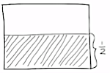
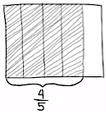
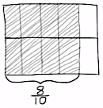
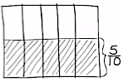
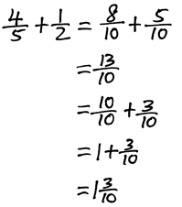
T: Can you share your answer, the sum, with us?
S: 1 and 1 fourth.

Problem 2: $\frac{4}{5}+\frac{1}{2}$
T: (Write $\frac{4}{5}+\frac{1}{2}$.) Solve this problem.
S: (Solve.)
T: Share with your partner how to express 13 tenths as a mixed number.
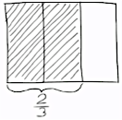
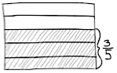
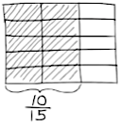
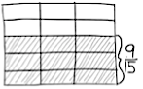
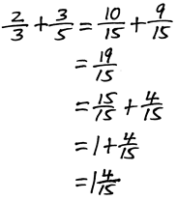
S: 10 tenths plus 3 tenths equals 13 tenths. 10 tenths makes a whole and 3 tenths is left over.
The sum is 1 and $\frac{3}{10}$ .
Problem 3: $\frac{2}{3}+\frac{3}{5}$
T: (Write $\frac{2}{3}+\frac{3}{5}$.) Let’s try another. Both addends have numerators greater than one, so make sure your brackets are clear. Draw the model you will use to solve.
S: (Draw.)
T: Discuss with your partner what you bracketed and why. I'll walk around to see how it's going. (Allow one minute for students to discuss.)
T: What's another way to express $\frac{19}{15}$ ?
S: Write it as a mixed number.
T: Do that now individually. (Allow 1 minute to work.) Compare your work with your partner.
What is the sum of 2 thirds plus 3 fifths?
S: 1 and 4 fifteenths.
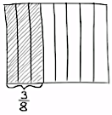
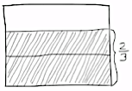
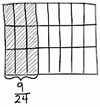
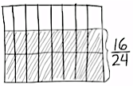
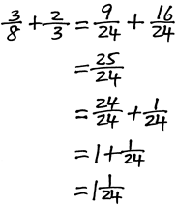
Problem 4: $\frac{3}{8}+\frac{2}{3}$
T: (Write $\frac{3}{8}+\frac{2}{3}$.) Try to solve this problem on your own. Draw a rectangular fraction model, and write a number sentence. Once everyone is finished, we will check your work.
S: (Work.)
T: What’s the like unit or common denominator for eighths and thirds?
S: Twenty-fourths.
T: Say your addition sentence using twenty-fourths.
S: 9 twenty-fourths plus 16 twenty-fourths equals 25 twenty-fourths.
T: How can $\frac{25}{24}$ be changed to a mixed number?
S: 25 twenty-fourths = 24 twenty-fourths + 1 twenty-fourth.
T: What’s another way to express $\frac{24}{24}$?
S: 1 whole.
T: Say the sum of 3 eighths plus 2 thirds.
S: 1 and 1 twenty-fourth.
Problem Set (10 minutes)
Students should do their personal best to complete the Problem Set within the allotted 10 minutes. For some classes, it may be appropriate to modify the assignment by specifying which problems they work on first. Some problems do not specify a method for solving. Students should solve these problems using the RDW approach used for Application Problems.
Student Debrief (10 minutes)
Lesson Objective: Add fractions with sums between 1 and 2.
The Student Debrief is intended to invite reflection and active processing of the total lesson experience.
Invite students to review their solutions for the Problem Set. They should check work by comparing answers with a partner before going over answers as a class. Look for misconceptions or misunderstandings that can be addressed in the Debrief. Guide students in a conversation to debrief the Problem Set and process the lesson.
T: Have your Problem Set ready to correct. I will say the addition expression. You say the sum as a mixed number. Problem 1(a), 2 thirds plus 1 half…?
S: 1 and 1 sixth.
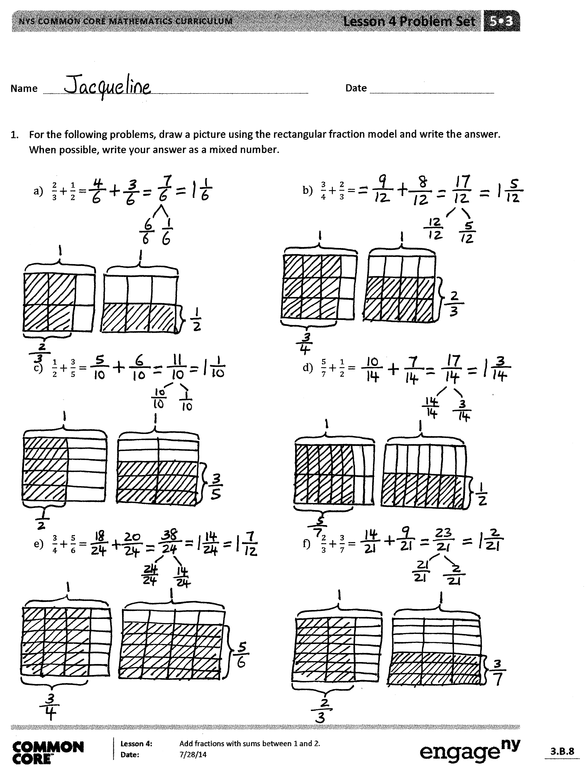
Continue in this way for the entire Problem Set.
T: I am going to give you 2 minutes to talk to your partner about any relationships you noticed on today’s Problem Set. Be specific.
Allow for students to discuss. Then, proceed with a similar conversation to the one below.
T: Ryan, I heard you talking about Problems 1(a) and (c). Can you share what you found with the class?
S: I saw that both problems used 1 half. So, I compared the second fraction and saw that they used $\frac{2}{3}$ in Problem 1 (a) and $\frac{3}{5}$ in Problem 1 (c). I remember from comparing fractions last year that $\frac{2}{3}$ is greater than $\frac{3}{5}$. It is really close. $\frac{2}{3}$ is $\frac{10}{15}$ and $\frac{3}{5}$ is $\frac{9}{15}$. So, the answers for 1 (a) and (c) also show that (a) is greater than (c) because (a) adds $\frac{2}{3}$ .
T: Thank you, Ryan. Can someone else share, please?
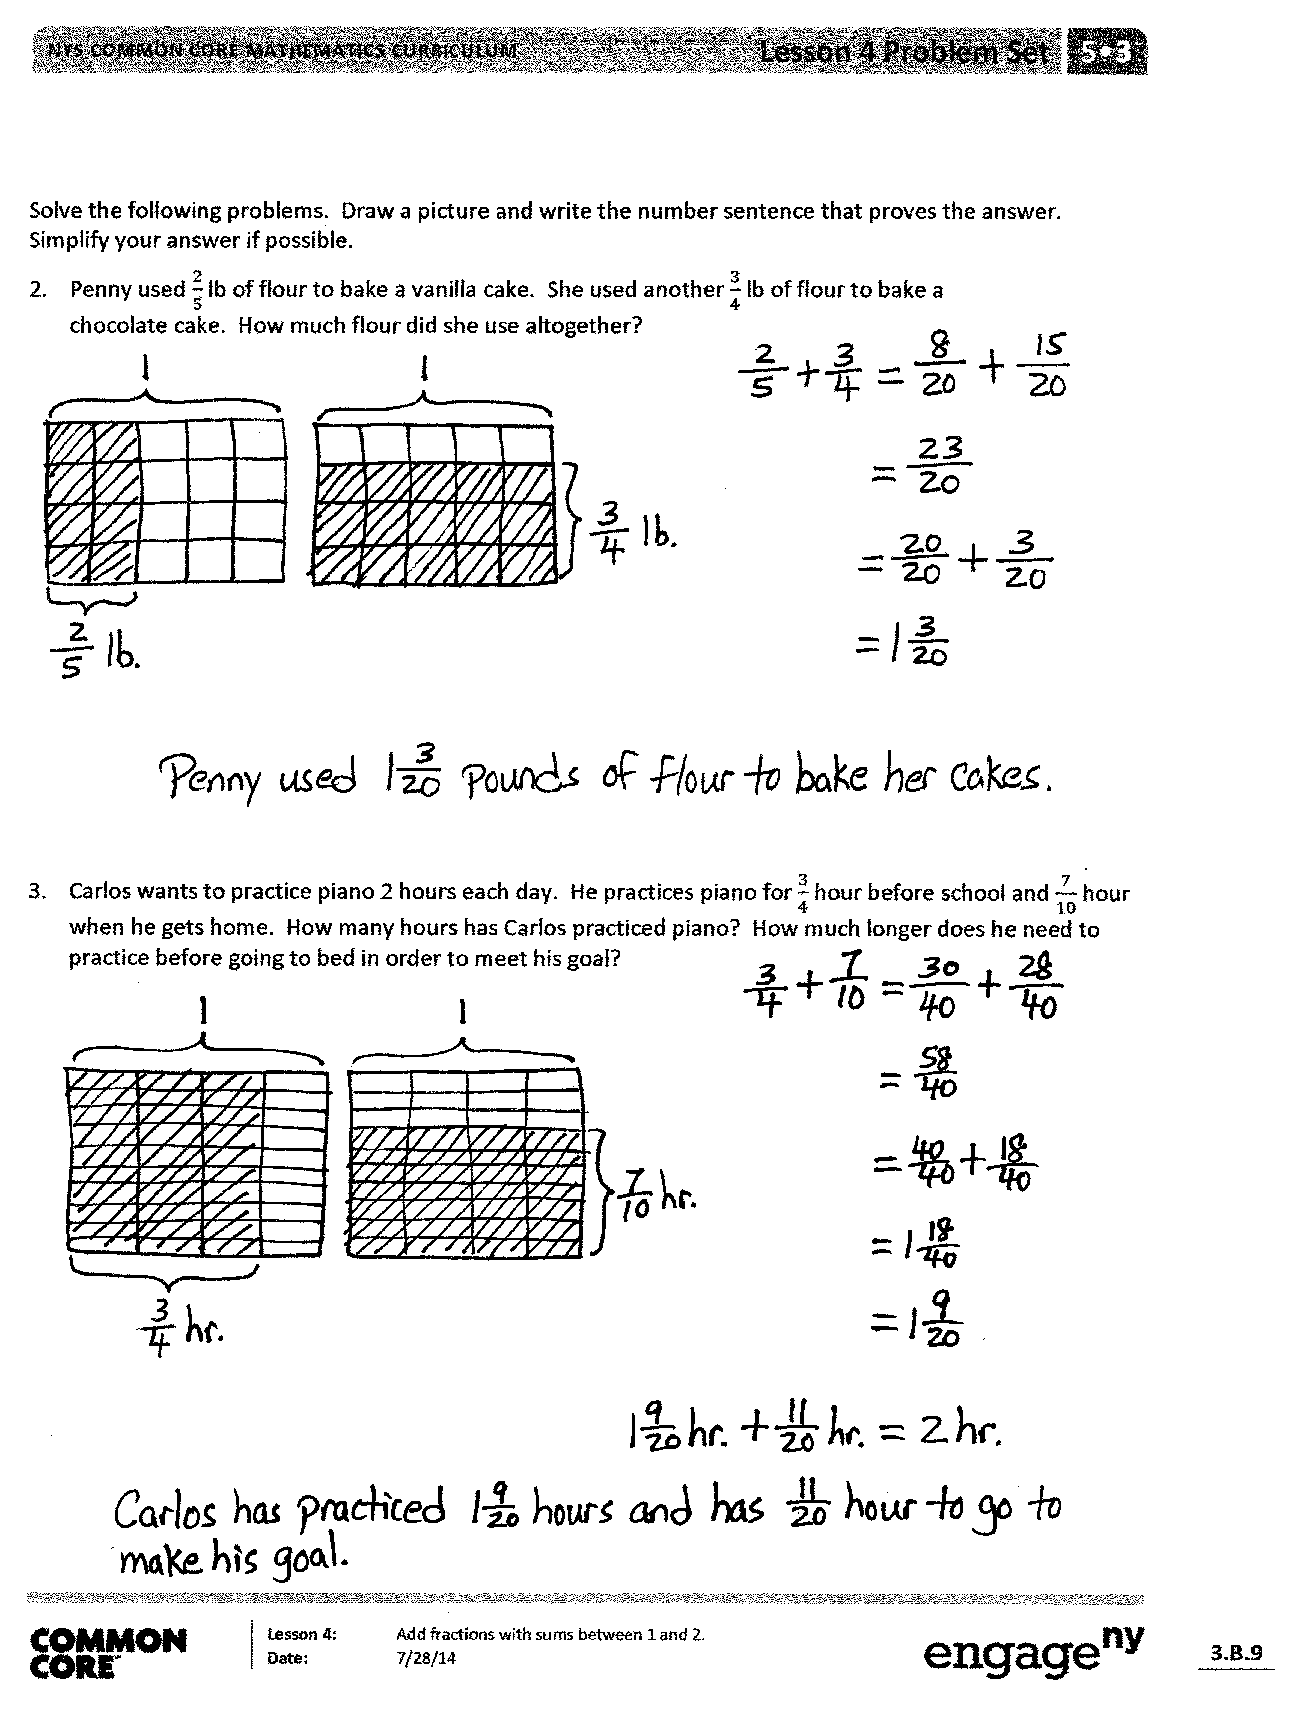
S: I noticed that every single fraction on this Problem Set is greater than or equal to one half. That means when I add two fractions that are greater than one half together, my answer will be greater than 1. That also means that I will have to change my answer to a mixed number.
T: Thank you. Now, I will give you 1 minute to look at Jacqueline’s work. What tool did she use to convert her fractions greater than 1 to mixed numbers?
S: Number bonds!
T: Turn and talk to your neighbor briefly about what you observe about her use of number bonds and how that compared with your conversion method.
T: What tool did you use to convert your fractions into like units?
S: The rectangle model.
T: (After students share.) How does this work today relate to our work yesterday?

S: Again, we took larger units and broke them into smaller equal units to find like denominators.
Yesterday, all of our answers were less than 1 whole. Today, we realized we could use the model when the sum is greater than 1. Our model doesn’t show the sum of the units. It just shows us the number of units that we must use to add. Yeah, that meant we didn’t have to draw a whole other rectangle. I get it better today than yesterday. Now, I really see what is happening.
T: Show me your learning on the Exit Ticket!
Exit Ticket (3 minutes)
After the Student Debrief, instruct students to complete the Exit Ticket. A review of their work will help you assess the students’ understanding of the concepts that were presented in the lesson today and plan more effectively for future lessons. You may read the questions aloud to the students.

Name Date
For the following problems, draw a picture using the rectangular fraction model and write the answer. When possible, write your answer as a mixed number.

- $\frac{2}{3}+\frac{1}{2}=$$\frac{2}{3}+\frac{1}{2}=$  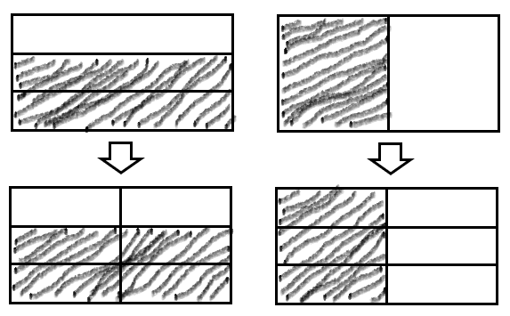 | - $\frac{3}{4}+\frac{2}{3}=$$\frac{3}{4}+\frac{2}{3}=$
- $\frac{1}{2}+\frac{3}{5}=$ | - $\frac{5}{7}+\frac{1}{2}=$$\frac{5}{7}+\frac{1}{2}=$
- $\frac{3}{4}+\frac{5}{6}=$$\frac{3}{4}+\frac{5}{6}=$ | - $\frac{2}{3}+\frac{3}{7}=$$\frac{2}{3}+\frac{3}{7}=$

Solve the following problems. Draw a picture, and write the number sentence that proves the answer.
Simplify your answer, if possible.
2. Penny used $\frac{2}{5}$ lb of flour to bake a vanilla cake. She used another $\frac{3}{4}$ lb of flour to bake a chocolate cake. How much flour did she use altogether?

Penny shared 2/5 of a cake with her friend, Rosie. Rosie also got 3/4 of a cake from another friend. Both cakes were the same size. How much cake does Rosie have now?

3. Carlos wants to practice piano 2 hours each day. He practices piano for $\frac{3}{4}$ hour before school and $\frac{7}{10}$ hour when he gets home. How many hours has Carlos practiced piano? How much longer does he need to practice before going to bed in order to meet his goal?

Name Date
- Draw a model to help solve $\frac{5}{6}+\frac{1}{4} .$ Write your answer as a mixed number.
What specific skills relate to students being able to show mastery.
- What is mastery?
  - Students being able to find like units, add fractional units, and name fractions over 1 as a mixed number.
- What skill did students need from previous grades (if applicable)?
  - Adding and adding fractional units
  - Calculating multiples
    - How can I use this information to plan for possible misconceptions?
      - Have students list multiples of each denominator to find the LCD
      - Ask students what are the units in the problem? Whether they are the same?
    - What is a scaffold to support students that are struggling?
      - Identify the unit for students
      - Draw representations of each and allow students to partition the pictorial representation.
      - List Multiples of one denominator to model for students
    - What resources can I provide to students?
      - Multiplication chart
      - Fraction Strips

2. Patrick drank $\frac{3}{4}$ liter of water Monday before jogging. He drank $\frac{4}{5}$ liter of water after his jog. How much water did Patrick drink altogether? Write your answer as a mixed number.

Name Date
For the following problems, draw a picture using the rectangular fraction model and write the answer. When possible, write your answer as a mixed number.

- $\frac{3}{4}+\frac{1}{3}=$$\frac{3}{4}+\frac{1}{3}=$ | - $\frac{3}{4}+\frac{2}{3}=$$\frac{3}{4}+\frac{2}{3}=$
- $\frac{1}{3}+\frac{3}{5}=$$\frac{1}{3}+\frac{3}{5}=$ | - $\frac{5}{6}+\frac{1}{2}=$$\frac{5}{6}+\frac{1}{2}=$
- $\frac{2}{3}+\frac{5}{6}=$$\frac{2}{3}+\frac{5}{6}=$ | - $\frac{4}{3}+\frac{4}{7}=$$\frac{4}{3}+\frac{4}{7}=$

Solve the following problems. Draw a picture, and write the number sentence that proves the answer. Simplify your answer, if possible.
- Sam made $\frac{2}{3}$ liter of punch and $\frac{3}{4}$ liter of tea to take to a party. How many liters of beverages did Sam bring to the party?

3. Mr. Sinofsky used $\frac{5}{8}$ of a tank of gas on a trip to visit relatives for the weekend and another 1 half of a tank commuting to work the next week. He then took another weekend trip and used $\frac{1}{4}$ tank of gas. How many tanks of gas did Mr. Sinofsky use altogether?

