Title/Author: From Seed to Plant by Gail Gibbons
Suggested Time to Spend: 10 Days (20 - 30 minutes per day)
Common Core grade-level K ELA/Literacy Standards: RI.K.1, RI.K.2, RI.K.3, RI.K.4, RI.K.7; W.K.2, W.K.8; SL.K.1, SL.K.2, SL.K.3, SL.K.4, SL.K.5, SL.K.6; L.K.1, L.K.2, L.K.5, L.K.6
Lesson Objective:
The student will understand the plant life cycle.

Teacher Instructions
Before the Lesson
- Read the Big Ideas and Key Understandings and the Synopsis below. Please do not read this to the students. This is a description to help you prepare to teach the book and be clear about what you want your children to take away from the work.

The book From Seed to Plant does not contain page numbers. For reference, we started page one on the page with the following sentence: “Most plants make seeds.”
Big Ideas/Key Understandings:
Plants and animals have predictable life cycles.
Synopsis
From Seed to Plant by Gail Gibbons is an informational text on the life cycle of plants and how the plants are used. This informational text provides a detailed description of flowers, their parts, pollination, the various ways that seeds move from place to place, and the life cycle of a plant. This book also touches on how we use plants, and has a project to grow a plant at the end.
- Go to the last page of the lesson and review “What Makes this Read-Aloud Complex.” This was created for you as part of the lesson and will give you guidance about what the lesson writers saw as the sources of complexity or key access points for this book. You will of course evaluate text complexity with your own students in mind, and make adjustments to the lesson pacing and even the suggested activities and questions.
- Read the entire book, adding your own insights to the understandings identified. Also note the stopping points for the text-inspired questions and activities. Hint: you may want to copy the questions vocabulary words and activities over onto sticky notes so they can be stuck to the right pages for each day’s questions and vocabulary work.

Note to teachers of English Language Learners (ELLs): Read Aloud Project Lessons are designed for children who cannot read yet for themselves. They are highly interactive and have many scaffolds built into the brief daily lessons to support reading comprehension. Because of this, they are filled with scaffolds that are appropriate for English Language Learners who, by definition, are developing language and learning to read (English). This read aloud text includes complex features which offer many opportunities for learning, but at the same time includes supports and structures to make the text accessible to even the youngest students.
This lesson includes features that align to best practices for supporting English Language Learners. Some of the supports you may see built into this, and /or other Read Aloud Project lessons, assist non-native speakers in the following ways:

- These lessons include embedded vocabulary scaffolds that help students acquire new vocabulary in the context of reading. They feature multi-modal ways of learning new words, including prompts for where to use visual representations, the inclusion of student-friendly definitions, built-in opportunities to use newly acquired vocabulary through discussion or activities, and featured academic vocabulary for deeper study.
- These lessons also include embedded scaffolds to help students make meaning of the text itself. It calls out opportunities for paired or small group discussion, includes recommendations for ways in which visuals, videos, and/or graphic organizers could aid in understanding, provides a mix of questions (both factual and inferential) to guide students gradually toward deeper understanding, and offers recommendations for supplementary texts to build background knowledge supporting the content in the anchor text.
- These lessons feature embedded supports to aid students in developing their overall language and communication skills by featuring scaffolds such as sentence frames for discussion and written work (more guidance available here) as well as writing opportunities (and the inclusion of graphic organizers to scaffold the writing process). These supports help students develop and use newly acquired vocabulary and text-based content knowledge.

The Lesson – Questions, Activities, and Tasks

Questions/Activities/Vocabulary/Tasks | Expected Outcome or Response (for each)
DAY 1-2 | Expected Outcome or Response (for each)
First Reading:  - Read aloud pages 1-19 straight through without stopping.*Because of the length of this book and complexity of the text, the teacher may chunk the text instead of reading the whole book at one time.  - Project the text so students can enjoy the illustrations.  Create a class KQ chart (see example).  Second Reading:  - Reread pages 1-19, Focus on asking questions as you go. Have students answer chart questions as you go.  - Engage students in a class discussion of plants to build background and complete the chart.  Chart Questions:  1. (pgs. 1-4) What can you tell me about seeds?  2. (pgs.5-6) What did we read about plant parts?  3. (pgs. 7-10) What are some ways plants can be pollinated?  - Put students in pairs or groups, give them a category and let them think of 1 question they want answered from that category. | This would be an excellent time to have students plant bean seeds (extension act.) and start a journal so they can record or draw daily changes. They can begin or end each daily lesson with journaling.  KQ Chart  Chart:  - Allow several students to give their ideas about questions 1 – 3. Then decide as a group what you want to put under the heading “What we already know”  - Put each pair or group’s question on the chart under questions we have
  Plant Topic | What we already Know…. | Questions we have…..
  Seeds
  Plant Parts
  Pollination
Day 3-4
Third Reading:  - Reread pages 1-19, Focus on asking questions as you go. Read a page; ask the question to help build comprehension.  - Project the text so students can enjoy the illustrations.  Questions:  1. (pg. 1.) What do most plants make? What do seeds contain?  2. (pg. 2) What did this page say seeds look like?  3. (pg.3) The author says that all seeds grow into the same kind of plant that made them. That means that if you plant a sunflower seed, it will grow into a sunflower. What would a bean seed grow into? (Continue with a few more examples, and then let students give you an example or two.  4. (pg.4) Where do most seeds start?  5. (pg.5) Read the parts of the flower to students. Have them point to the stem and the petals  6. (pg.6) What is pollination?  7. (pg.7) What is one way plants are pollinated?  8. (pgs. 8-9) Name 2 more ways the author says plants are pollinated.  9. (pgs. 10-11) Where does the seed grow? What protects the seed? (Ask students to name some fruits where they have seen seeds inside)  10. (pgs. 12) What happens when the fruit or pod becomes ripe? Have you ever heard the word ripe or ripen? Do you know what it means?  11. (pgs. 13 – 17) How are seeds scattered? (Be sure students understand what scattered means – to go in different directions)  12. (pgs. 18-19) How do people use seeds? (Discuss any time students helped plant seeds at home.) | 1. seeds; the beginning of a new plant  2. All different shapes, sizes, colors  3. A bean.  4. In the flower.  - Have students point out the stem and petals  - New seeds are started when pollen moves from one flower to the next.  - Wind  - Bees and birds  - Inside the flower; The fruit or pod (various answers)  - It opens and the seeds fall out. If students don’t know what ripe means, lead them to the definition: fully mature fruit (Put it in terms of ready to eat)  - Read pages 13 – 17 asking how the seeds were scattered on each page  13 – fall to the ground  14 – birds drop them  15 – water takes them  16 – wind scatters them  17 – animals scatter them  - To plant flowers and vegetables; student discussion  Add these words to a word wall where students can use them in future writing activities: plant, seed, flower, stem, petals, pollination, fruit, pod, scattered, ripen
DAY 5
Fourth Reading:  - Reread pages 12-17 aloud and focus on ways seeds are scattered. If possible, bring in some examples of seeds for students to look at.  - Class Discussion:  (pg. 12) Review what ripen means in the context of when the fruit ripens the seeds are ready to be scattered and become new plants.  (pg. 13) Bring up the word “scattered” here again to be sure students understand it’s meaning so they understand that pgs. 13 – 17 are all talking about how seeds are scattered even if it doesn’t use the word. Continue reading 14 – 17 straight through.  Shared Writing:  Create a class chart for how seeds are scattered. This can be a concept web with the words “How seeds are scattered” in the middle. As you ask the following questions, add bubbles for each new way discussed. (Because students probably won’t be able to read the words, you may draw pictures in the web along with the words or you may use the pictures at end of the lesson that show examples of how seeds are scattered as well as words)  Questions:  Read each page and then ask the question that goes with it. Fill in the chart as you go.  - (pg.13) What did the book say was one way seeds are scattered?  - (pg. 14) How do birds help scatter seeds?  - (pg. 15) What does this page say about how seeds are scattered?  - (pg. 16) How can the wind scatter seeds?  - (pg.17) What else helps scatter seeds? | Various examples of seeds, or pictures of seeds. Try to find the ones like in the book to bring it alive for students. Let students touch, feel, describe the seeds before reading.  Sample concept web for shared writing  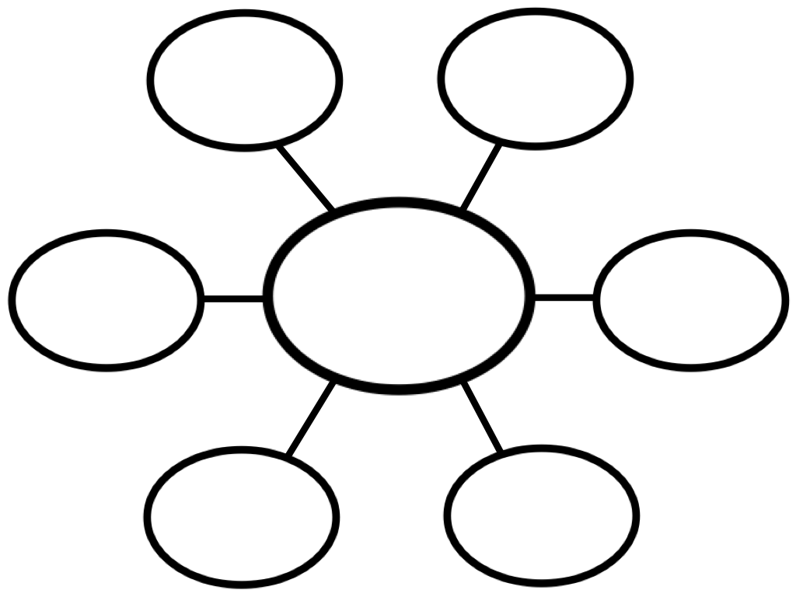  - They just fall to the ground and start growing there.  - The birds eat the seeds and drop some.  - They fall into the water and travel until they stick to the dirt.  - Some seeds have fluff on them that lets them float, some are like little parachutes, and some have wings. (show examples of these if you can)  - Animals and people (again, show examples of seeds if possible)
DAY 6
First Reading:  - Read pages 20-27 aloud without stopping, projecting illustrations for students to see.  - Reread pages 20 -23 and discuss the action words in the text: (curled, stored, protect, sprout, soak, soften, breaks, grows)  - Project illustrations from the text to support students in understanding the meaning of the terminology.  Discussion/questions:  (pg. 20) After reading this page, ask students if they have ever “curled up” on their mother’s lap. If they have ever seen a cat “curled up” by the fire. Lead them to see that curled means to fold up and make yourself smaller to fit in a spot. Then ask:  - Who can tell me why they said the leaf was curled up inside the seed?  Next discuss how squirrels store food for winter in their nests so they will have it when they need it. Then ask;  - How does a seed store food?  This page also talks about a seed coat, ask students when they wear a coat and why. (when it is cold, to keep warm, to keep dry, etc.) Tell them that their coat “protects” them from the weather. Then ask  - What protects a seed?  (pg. 21) Read this page. How many of you have ever seen a plant that is just starting to grow? (If possible, show a picture of a plant just sprouting up from the ground) Tell students that when something just starts growing we call it sprouting. Discuss that a seed will not sprout until it is in soil and rained on. Then ask:  - What will this seed look like when it sprouts?  Ask students if they have ever been rained on. What happens to your clothes? (They get all wet). We call that getting “soaked”. Usually when your clothes get soaked, they stay wet for a while unless you dry them. Reread the sentence with the word soak in it.  - What does the word soak mean in the story?  What happens when you wet a cracker? Does it stay hard? (No, it gets soft)  - So when the seed gets wet and softens the seed coat, what happens to it?  (pg.22) Read this page. Ask what happens when an egg breaks open? (It cracks and a baby comes out) What about when you break open a piñata? (candy comes out). Then ask:  - What happens when the seed coat breaks open?  (pg.23) Read this page, then ask;  - What does it mean to grow up? What happens when you grow up?  - What do all these words have in common? | Allow students to act out any of these verbs to get them up and moving during the lesson.  Possible responses:  - Because it was folded up small inside the seed. (Let students act out “curling up” )  - It keeps it inside of the seed and uses it as needed.  - A seed coat  - Take all answers, then show them page 20 where the plant is curled up. Tell them that when it comes out of the seed it has sprouted. (Let students act out being a curled up seed and then “sprouting” open.)  - The seed gets wet and stays wet  - The seed coat gets soft  - The plant comes out  - Get bigger  - They show action  - Add bolded, italicized words to the word wall
DAY 7
Tell students that today we are going to learn about the life cycle of plants. Discuss that a cycle means it goes around and around (like a bicycle) A life cycle of a plant means that you start with a seed, it grows into a plant, it makes more seeds, and the process starts all over.  - Reread pages 20-27 aloud and focus on asking questions about the key vocabulary in the text related to plants and how they grow (e.g., seed coat, germination, root, soil, minerals, shoot, leaves, stem, bud, flower)  - Project illustrations from the text to support students in understanding the meaning of the terminology.  Discussion/Questions:  Show students pages 20 and 21, tell them that this illustration (pg. 20) shows the inside of a seed and the seed is the beginning of the plant’s life cycle.  1. What are we looking at on page 20?  Who remembers what we said about a coat? (protects us) Why does this seed have a coat? (protects it) What do we call the coat that protects the seed? (seed coat)  Look at pg. 21, Where is the seed? (in the ground) What is the weather doing? (raining) Remember we said that a seed needs dirt and rain to sprout, is that happening in this picture? (yes) What is going to happen when the seed sprouts? (It will break apart and start to grow)  Look at page22. Now that the seed has been planted and has sprouted, another part of its life cycle is happening here. Listen as I read this page again to hear what word means to break open and begin to grow. Reread the page stressing the word germination.  2. What do we call it when a seed starts to grow? (pg.22)  Reread the sentence: A root grows down into the soil. Point out the root in the picture.  Ask:  3. Who can tell me what word I used in this sentence that means the same as dirt?  Listen to this sentence: “The root takes in water and minerals from the soil for food.”  4. What can we say that minerals are to plants?  Show page 23 - Here is the next picture in the life cycle.  5. What do you notice about this picture that makes it different from the picture on page 22?  Read page 23 – Now the plant is called a shoot. The sprout is underground; once it comes above ground, but still small, we call it a shoot. The shoot soon turns into a stem and has leaves growing out of it. Now the plant needs something else besides water and soil to grow, do you know what it is? (sun)  Read page 24 and 25.  6. Can you show me the bud on page 25? The bud is where a flower will form. The flower is the colorful part of the plant and will make seeds. Then the plant cycle will start all over again.  7. What color are the flower petals in this picture?  8. Read pgs. 26-27. Show students the pictures. Can you find some seeds? Fruits? Pods? | - The words in bold are important vocabulary words for students to know in order to fully understand the plant life cycle.  - As you and your students define the bolded words, write the words and definitions on a class chart to be displayed. You can use the book illustrations as well.  - The inside of a seed that is in the ground. (a close-up of the seed on page 21)  seed coat – outside coating that protects the seed  - germination, point out the word in the text  root – the part of a plant that is under ground and takes in food and water  - soil, point to it in the text  - Minerals-are what plants use for food. The plants get the minerals through their roots, as well as water.  - Lead students to see that the plant is now “above” the soil.  shoot- a sprout that is not three feet high  leaves – one of the flat and typically green parts of a plant that grow from a stem  stem - a plant part that supports the leaves and flowers  bud- the beginning of a flower  flower – the colorful part of a plant that makes the seeds  6. Let student come point to the bud. If the time of year is right, ask students to find some buds at home. You can also bring in some pictures that you have taken of buds.  7. White, remind students that the petals are the colorful part of the flower.  - Add all bold words to the word wall  8. Allow students to point to examples  (Have students go back in their journals and label their pictures with the correct vocabulary word that matches the stage of growth. This could best be done as a small group, T. directed activity.)
DAY 8
Shared Writing Task:  - Conduct a shared writing task in which students describe the life cycle of a plant.  - Record the cycle onto a chart labeled Plant Life Cycle. *  - Use illustrations and words, allowing students to orally tell you what comes next. Teacher leads students to the correct answers.  Questions:  What comes 1st in the life cycle of a plant? (seed is planted – review ways seeds get scattered and planted) 2nd ? (it germinates and the seed coat breaks open. The plant starts to grow a shoot and roots) 3rd? (The shoot comes above ground and becomes a stem) 4th? (Leaves grow out of the stem) 5th? (A flower grows and makes new seeds) Then the cycle starts over. | - In a shared writing activity, the teacher will draw the plant life cycle on chart paper as the students help describe it and decide what to draw/write.  - There is an exemplar chart you can use for guidance at the end of this lesson.*  Plant Life Cycle
  1st | 2nd | 3rd | 4th | 5th
Day 9
Final Reading:  Reread From Plant to Seed: pages 1-27 aloud, having students listen for all the vocabulary words they have learned.  Question:  - Review the vocabulary from the chart done on day 7. Say a word, show them the picture from the book, and ask students to define it.  - Review the plant life cycle from shared writing task on day 8.  - Put students in small groups. Give each group the Parts of a Plant worksheet (at end of unit) and let them use the class charts to fill in the parts. Then let them color it. (Each student should have their own copy, groups may work together to fill it in) | - Allow several students to answer  Key  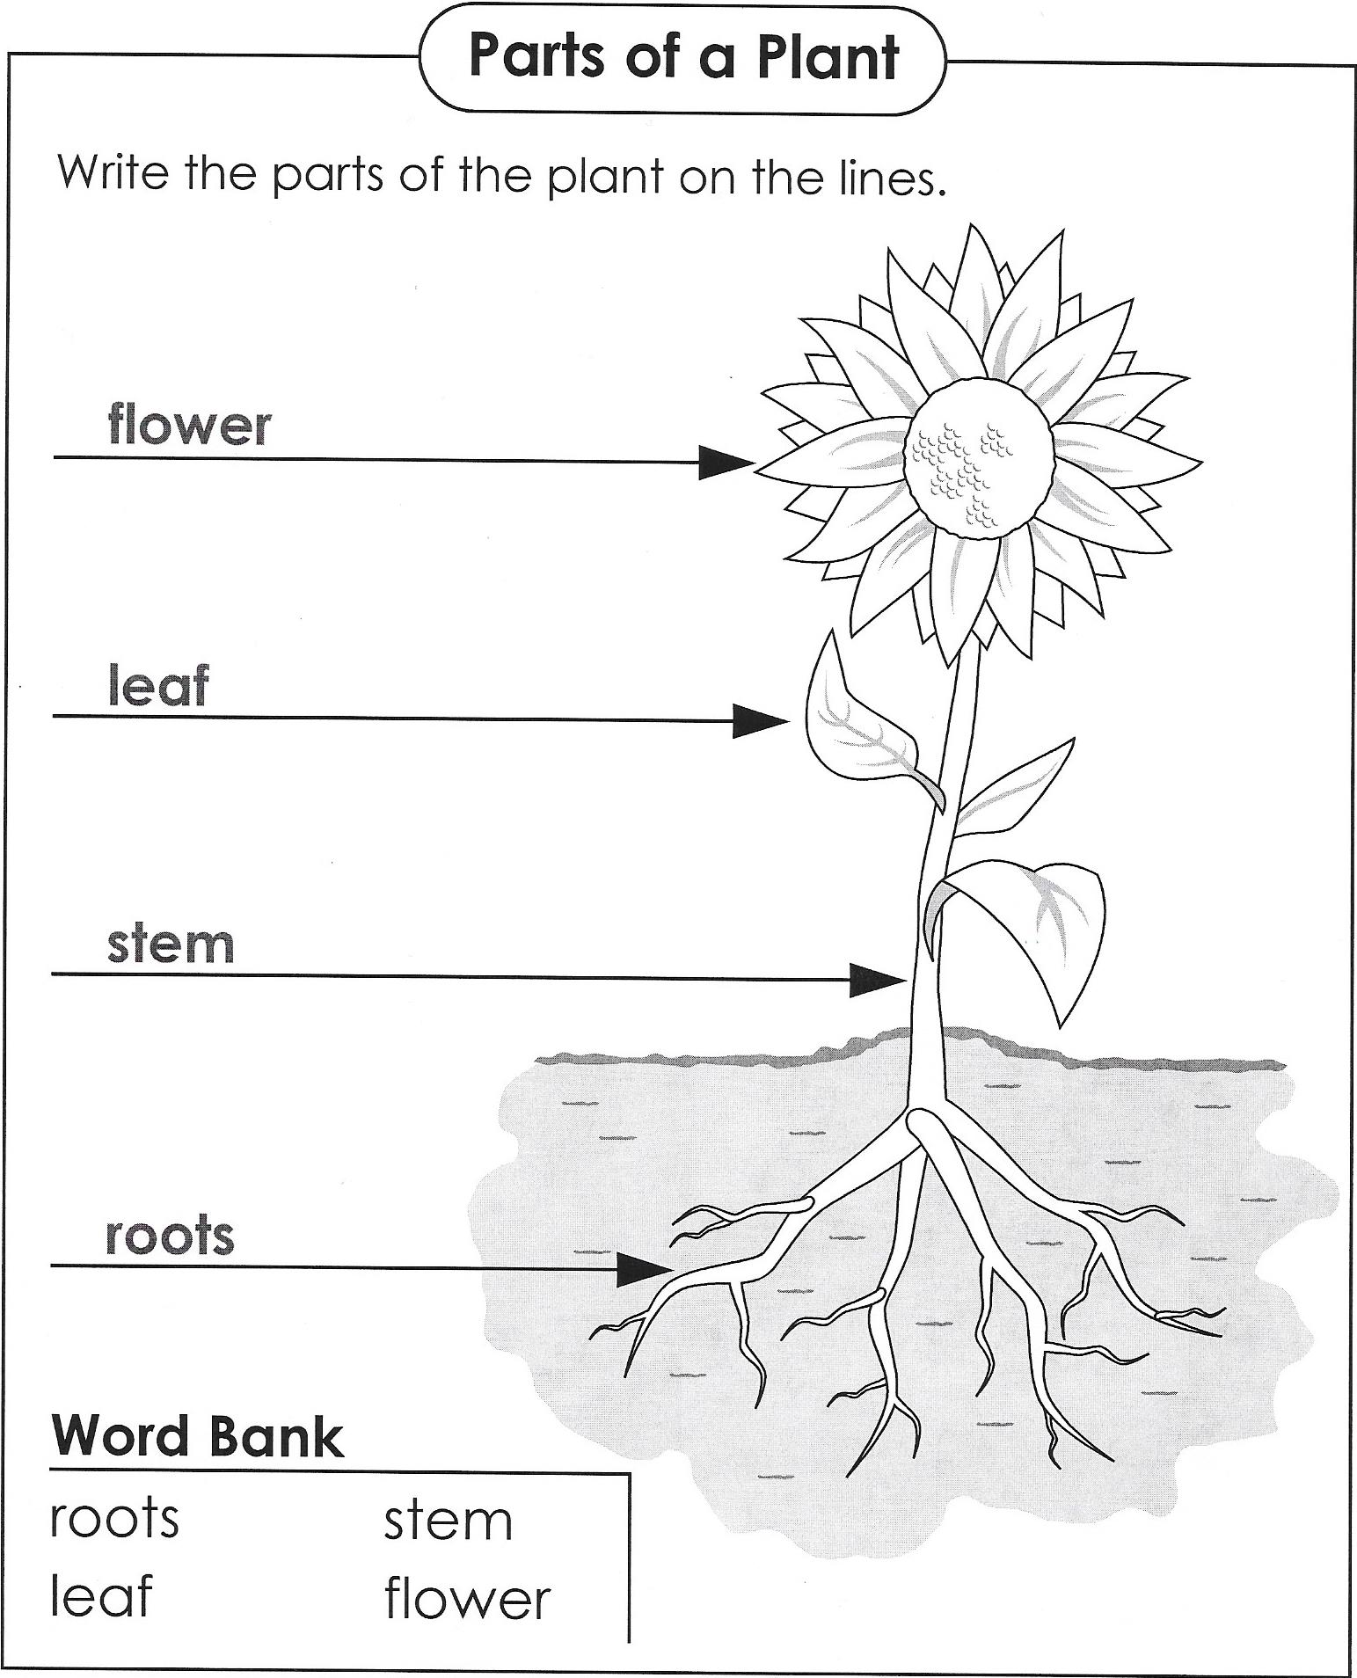

DAY 10: FINAL DAY WITH THE BOOK - Culminating Task
Student Writing:
Each student will recreate the plant life cycle using the class charts for support.
- Provide sentence frames for students who need support writing complete sentences. (see below)
- Have student draw a picture that shows what is happening in each sentence.
- This will be put together to create a class book.
- Create a rubric to assess student work. (You can use the exemplar to create your rubric)

Sentence Frame for students who need support:
Plant Life Cycle

The ___________  is planted in the ground. It needs water. | The ____________ grow down. | The _____________ grows up. | The _____________ grow next. | Then there is a __________________. It makes more seeds.
Vocabulary
These words merit less time and attention  (They are concrete and easy to explain, or describe events/  processes/ideas/concepts/experiences that are familiar to your students.) | These words merit more time and attention  (They are abstract, have multiple meanings, and/or are a part  of a large family of words with related meanings. These words are likely to describe events, ideas, processes or experiences that most of your student will be unfamiliar with)
Page 1:  Plant-living things that grow in ground or water  Seed(s)-small, protected parts of a plant that are able to grow into a new plant  Page 5:  Flower-part of the plant where the seeds are  Petal-the colorful part of the flower  Page 6:  Pollination- pollen moves from the stamen of one flower to the stigma of another flower like itself.  Page 12:  Ripen – a fruit or pod reaches full growth  Page 16:  Scatter - to separate and go in different directions  Page 23;  Leaves-parts of the plant that make food for the plant | Page 20:  Seed Coat-outside coat that protects the seed  Page 21:  Soil-top layer of dirt where seeds or plants are planted  Page 22:  Root –parts of the plant that keep it in the ground and take up food and water  Germination-to start to grow  Minerals-nutrients that are in the soil  Page 23:  Shoot-a sprout that is not three feet high  Page 24:  Stem –a plant part that supports the leaves and flowers  Page 25:  Buds-are unopened flowers

Extension learning activities for this book and other useful resources
A “From Seed to Plant” Project pages 28-29.
Students will plant a bean seed and observe it as it grows. Provide and word bank for students with vocabulary from the text. Students draw and label pictures daily in a journal to record their observations and apply their vocabulary. Encourage students to share their observations and compare them to plants they see outside. Note: This is particularly supportive of English Language Learners.

What Makes This Read-Aloud Complex?
- Quantitative Measure
Go to http://www.lexile.com/ and enter the title of your read-aloud in the Quick Book Search in the upper right of home page. Most texts will have a Lexile measure in this database.

Most of the texts that we read aloud in K-2 should be in the 2-3 or 4-5 band, more complex than the students can read themselves.
2-3 band 420-820L
4-5 band 740-1010L

__660__

- Qualitative Features
Consider the four dimensions of text complexity below. For each dimension*, note specific examples from the text that make it more or less
complex.
In-depth look at plant life cycle, plant parts
- Describes how pollination occurs
- Explores complex concepts
- Lots of information in the illustrations
- Detailed parts labeled
- Plant Cycle sequenced

- Many Content-specific vocabulary words
- Simple sentences
- One or two sentences per page, under pictures

- What a plant is
- The concept of a flower

Structure
Meaning/Purpose

Knowledge Demands
Language

*For more information on the qualitative dimensions of text complexity, visit http://www.achievethecore.org/content/upload/Companion_to_Qualitative_Scale_Features_Explained.pdf
- Reader and Task Considerations
What will challenge my students most in this text? What supports can I provide?
The vocabulary will be challenging. We will need to discuss these content specific words on numerous occasions, practice using them during the lessons, and place them on a word wall.

How will this text help my students build knowledge about the world?
Understanding the life cycle of a plant is basic knowledge that all students should possess. Everyone interacts with plants throughout their lives, whether they raise a garden, or buy fruits and vegetables from a grocery store. Either way, they need to understand where they come from and how they produce more.

- Grade level
What grade does this book best belong in?
This book is suited as a read-aloud for Kindergarten, although I would suggest using it after mid-term due to its complexity.

Resources:

Exemplar for: The Life Cycle of a Plant

You can use this as a model for Life Cycle of a Plant chart on day 8 – shared writing activity, and the culminating writing activity
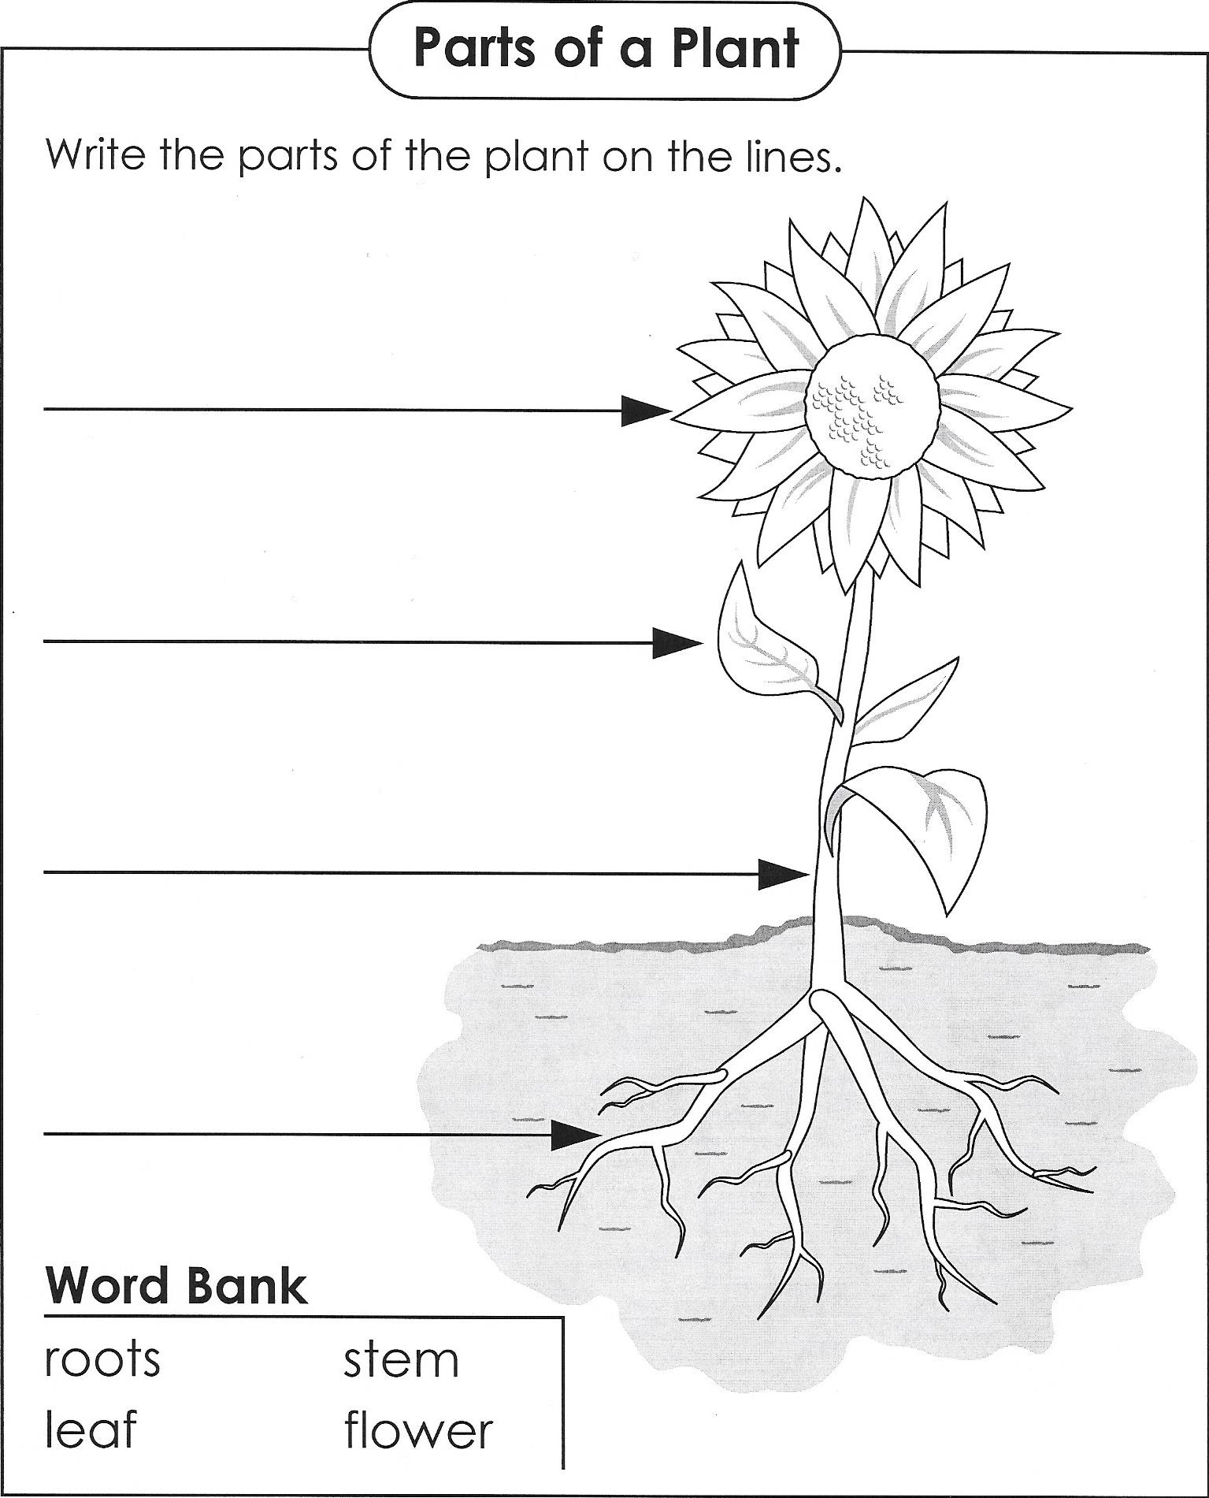
For use with the concept web on day 5.

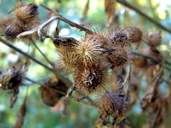
Burrs – stick to people and animals

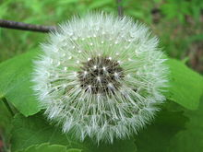
Wind

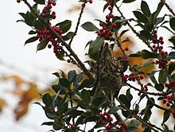
Dropped by birds

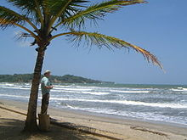
Water

All content linked to within this resource was free for use when this resource was published in March 2018. Over time, the organizations that manage that external content may move or remove it or change the permissions. If the content is no longer available, please email info@studentsachieve.net.

