Title/Author: “Jackrabbit”, a poem from Desert Voices by Byrd Baylor
Suggested Time to Spend: 4 Days (Recommendation: one session per day, at least 20 minutes)
Common Core grade-level ELA/Literacy Standards: RL.K.1, RL.K.2, RL.K.3, RL.K.7, RL.K.10; W.K.2, W.K.8; SL.K.1, SL.K.2, SL.K.5, SL.K.6, L.K.1
Next Generation Science Standards: K-LS1-1; K-ESS3-1
Lesson Objective:
- Students will listen to a poem read aloud, determining the central idea and identifying and summarizing key ideas and details that support them in their analysis.
- Students will compare two texts, extracting details that support a main topic.
(Clarification: This poem is intended to be the second part of a paired reading and should follow the RAP lesson on the book: Cactus Hotel. Students will identify physical traits and characteristics of organisms that support survival in an interdependent ecosystem.)

Teacher Instructions:
NOTE: Samples of student work are provided in the final pages of this packet.
Before the Lesson
- Read the Big Ideas and Key Understandings and the Synopsis below. Please do not read this to the students. This is a description to help you prepare to teach the book and be clear about what you want your children to take away from the work.
Big Ideas/Key Understandings/Focusing Question
- Big Idea: Physical traits and characteristics of organisms support their survival in an interdependent ecosystem.
- Focusing Question: How do physical traits and characteristics of organisms help them survive within an interdependent ecosystem?
Synopsis
Within the context of a predator and prey scenario, the poem, “Jackrabbit,” conveys how physical traits and characteristics of a jackrabbit help it to survive. The jackrabbit uses stealthy behaviors, such as hiding in holes to avoid predators. Its body structure allows it to quickly adjust its movements to help it avoid predators. As suggested by the poem, almost instinctively the jackrabbit knows when to run and when to hide. Its long ears not only help it hear “every sound”; but, by adjusting its ears when running, its body becomes more streamline allowing it to move quickly.
Additional facts about the jackrabbit are identified in the “Culminating Activity” section of this lesson template. After reading and discussing this poem, as well as reading the book “Cactus Hotel”, the class will develop a chart identifying survival traits and characteristics of cacti and jackrabbits. Students will then draw two pictures using two separate sheets of paper. On one sheet, students will draw a picture and write one sentence describing a physical trait or characteristic that helps cacti survive. On the other sheet, students will draw a picture and write a sentence describing a physical trait or characteristic that helps jackrabbits survive in their ecosystem.

[This poem is intended to be the second part of a paired reading and should follow the RAP lesson on the book: “Cactus Hotel”. This lesson will focus on the main topic, being how physical traits and characteristics help organisms survive in an interdependent ecosystem.]
- Go to the last page of the lesson and review “What Makes This Read-Aloud Complex.” This was created for you as part of the lesson and will give you guidance about what the lesson writers saw as the sources of complexity or key access points for this book. You will of course evaluate text complexity with your own students in mind, and make adjustments to the lesson pacing and even the suggested activities and questions.
- Read the poem, adding your own insights to the understandings identified. Also note the stopping points for the text-inspired questions and activities. Hint: You may want to copy the questions, vocabulary words, and activities over onto sticky notes so they can be stuck to the appropriate sections of the poem for each day’s questions and vocabulary work.

Note to teachers of English Language Learners (ELLs): Read Aloud Project Lessons are designed for children who cannot read yet for themselves. They are highly interactive and have many scaffolds built into the brief daily lessons to support reading comprehension. Because of this, they are filled with scaffolds that are appropriate for English Language Learners who, by definition, are developing language and learning to read (English). This read aloud text includes complex features which offer many opportunities for learning, but at the same time includes supports and structures to make the text accessible to even the youngest students.
This lesson includes features that align to best practices for supporting English Language Learners. Some of the supports you may see built into this, and /or other Read Aloud Project lessons, assist non-native speakers in the following ways:

- These lessons include embedded vocabulary scaffolds that help students acquire new vocabulary in the context of reading. They feature multi-modal ways of learning new words, including prompts for where to use visual representations, the inclusion of student-friendly definitions, built-in opportunities to use newly acquired vocabulary through discussion or activities, and featured academic vocabulary for deeper study.
- These lessons also include embedded scaffolds to help students make meaning of the text itself. It calls out opportunities for paired or small group discussion, includes recommendations for ways in which visuals, videos, and/or graphic organizers could aid in understanding, provides a mix of questions (both factual and inferential) to guide students gradually toward deeper understanding, and offers recommendations for supplementary texts to build background knowledge supporting the content in the anchor text.
- These lessons feature embedded supports to aid students in developing their overall language and communication skills by featuring scaffolds such as sentence frames for discussion and written work (more guidance available here) as well as writing opportunities (and the inclusion of graphic organizers to scaffold the writing process). These supports help students develop and use newly acquired vocabulary and text-based content knowledge.

The Lesson – Questions, Activities, and Tasks
*When referring to line numbers, note that blank lines between stanzas were assigned line numbers.
Questions/Activities/Vocabulary/Tasks | Expected Outcome or Response (for each)
FIRST READING:  Read aloud poem with minimal interruptions. Stop to provide word meanings or clarify only when you know the majority of your students will be confused. | The goal here is for students to enjoy the poem, both text and pictures that accompany the text, and to experience it as a whole. This will give them some context and sense of completion before they dive into examining it more carefully.
SECOND READING:  Lines 1-4  What words does the author use to show jackrabbit is quick?  What is a leap?  Lines 4-6  What does jackrabbit need to know?  Why does the jackrabbit need to know these things?  ____________________________________________________  Lines 11-14  Optional (See comments.) When did jackrabbit learn these things?  Who is the “I” (on line 13)?  Lines 16-23  The author says the jackrabbit lies “…on the shadow-side of a clump of grass.” Why does the jackrabbit choose the shadow-side?  What physical characteristics help the jackrabbit to hear?  What does the jackrabbit hear? Why does the author choose these examples?  Why are hearing these sounds important?  ____________________________________________________  Lines 25-33  How do the words, phases, and blank lines change the way the reader reads this text?  How do you know that this is a poem?  __________________________________________________  Lines 34-54  How does the jackrabbit move?  What else does the jackrabbit do on his way?  Who is jackrabbit’s enemy?  What did you hear in the poem that helped you to understand that the coyote and jackrabbit are enemies?  What does coyote want to do?  Show pictures from the poem and from pages 10, 11, 20, and 21 in the book: Cactus Hotel.  Where does he go when he disappears?  Lines 55-62  What does jackrabbit mean by, “Let Coyote stand there sniffing old jackrabbit trails?”  What is jackrabbit’s secret? | - sudden leap, instant start, burst of speed  - a jump with a long high arch  - “when to run and when to freeze, how to become a shadow” (Clarify freeze is to stay still, not cold)  - For protection and survival  ____________________________________________________  – “almost at birth” (Learned behavior vs. Instinctual - Teachers have the autonomy to pull address this concept based on their students and standards.)  -the jackrabbit  ____________________________________________________  -dark, hidden  -long ears  -The jackrabbit hears every far-off footstep, every twig that snaps, every rustle in the weeds. The author choses these examples to convey the exceptional hearing that the jackrabbit has.  - so the jackrabbit can stay safe from predators and survive in the ecosystem  ______________________________________________________  - To slow the reader down. And to build suspense – a feeling or state of nervousness or excitement caused by wondering what will happen  - The ability for students to answer this question will depend on the background knowledge of poetry elements and structure. Teachers may need to provide direct instruction on elements and structure of poetry prior to asking this question. (rhythm, patterns, imagery etc.)  ___________________________________________________  - Jumping high, doubling back, circling. Explain vocabulary: zig-zag, sail, doubling back, and circling. Consider having students draw and/or act out movements.  -He jumps high to see his enemy, he warns other jackrabbits, and he disappears  - Coyote  - The jackrabbit is hiding from the coyote. The jackrabbit is running from the coyote.  - The coyote wants to eat Jackrabbit.  Students will describe Jackrabbits behaviors on each page.  Pages 10-11: “When the coyote moves in the distance, the jackrabbit disappears into a nearby hole.  Pages 20-21: “All around the desert there are holes of every size” offering shelter and protection for many insects and animals. A jackrabbit can be seen in a hole.  In the “Cactus Hotel”, the jackrabbit hides in a hole. The poem does not specifically state where the jackrabbit hides. He is stealth like. He is very adept at hiding and fleeing predators. Jackrabbit is tricky …it’s a secret as to where he might be.  __________________________________________________  - The coyote is standing there unsure of where to look next because the jackrabbit is so quick. Jackrabbit knows that coyote is off his trail because his is sniffing “old” trails.  - Jackrabbit’s secret is that no one knows where Jackrabbit is due to his ability to escape from danger. He may be in a hole, hiding in brush, or increasing the distance between he and his predator using stealthy moves.
THIRD READING:

Culminating Activity

FINAL DAY WITH THE BOOK - Culminating Task (Days 3 and 4)
Making Connections: (2 Activities)
- Activity 1:
This activity is designed to make connections between the book, Cactus Hotel and the poem, “Jackrabbit”. In this activity students will identify physical and/or behavioral characteristics and traits of cacti and jackrabbits that allow survival within their ecosystem.
Step 1 (Day 3):
- Develop and complete a chart with content information similar to the one below. Include pictures and illustrations, to help complete the chart, when possible. (Broaden to plural form to develop their skill of generalization.)
- Please note, teachers may consider rereading Cactus Hotel before completing this chart.
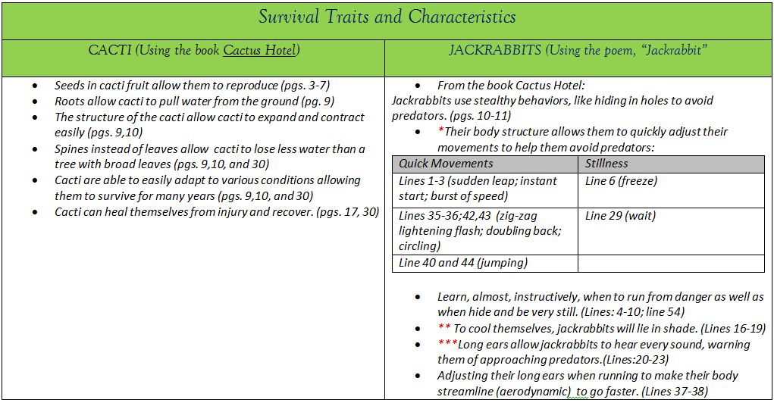

*Fun Fact – Jackrabbits can reach speeds of up to 40 mph. “Their powerful hind legs can propel them on leaps of more than ten feet They use these leaps and a zigzag running style to evade their many predators.”(“Jackrabbit”, National Geographic online)
**Fun Fact - Jackrabbits … often rest in the shade during the heat of the day in a shallow depression under grass or bushes. They do not live in burrows. They will often forage or rest in groups relying on the eyes and ears of each other for protection. (“Animal Fact Sheet: Black-tailed Jackrabbit”, Arizona-Sonora Desert Museum)
***Fun Fact: “… large ears of this hare help it to lose heat and thereby cooling its body temperature. They have large eyes that are high on their head and placed toward the side. This along with the fact that their head is slightly flat allows them to see almost 360 degrees helping to spot predators.” (“Animal Fact Sheet: Black-tailed Jackrabbit”, Arizona-Sonora Desert Museum)
Fun Facts taken from National Geographic and Arizona-Sonora Desert Museum: http://animals.nationalgeographic.com/animals/mammals/jackrabbit/
https://www.desertmuseum.org/kids/oz/long-fact-sheets/Jackrabbit.php

Step 2 (Day 4):
- Students will need 2 pieces of lined paper with space provided for an illustration. See below for an example. On one sheet, students will draw a picture and write one sentence describing a physical trait or characteristic that helps cacti survive. On the other sheet, students will draw a picture and write a sentence describing a physical trait or characteristic that helps jackrabbits survive in their ecosystem.
- Sample answers: Provided below.

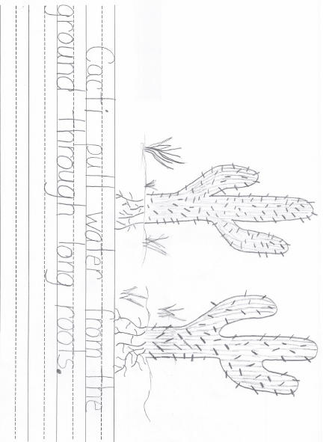
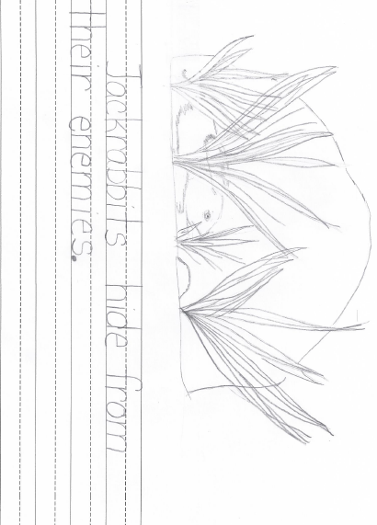
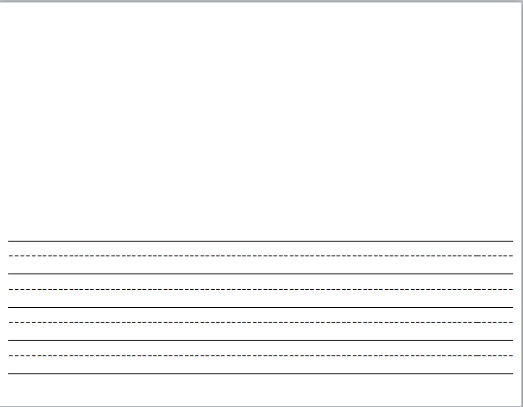
Vocabulary
These words merit less time and attention  (They are concrete and easy to explain, or describe events/  processes/ideas/concepts/experiences that are familiar to your students.) | These words merit more time and attention  (They are abstract, have multiple meanings, and/or are a part  of a large family of words with related meanings. These words are likely to describe events, ideas, processes or experiences that most of your student will be unfamiliar with)
*Essential to Understanding: Make sure the students understand the meaning or the word, “survive”(not specifically in the text)  - Active verbs that specifically describe movements:  Line # 1 – leap– To make a jump with a long high arch  Line 43 - circling  Line # 35 – zig-zag  - Other words:  - Line # 10 – greasewood bush  Line # 45 – enemy  Line#54 – disappear – point out prefix “dis” root word “appear”  Line # 40 – Gullies  Line # 58 - trials | These words have multiple meanings in English:  Line # 6 – freeze– to stop or remain still  Line # 23 – rustle– a swishing or soft crackling sound  Line #19 – clump–a group of growing things

Extension learning activities for this book and other useful resources
- Jackrabbit Video (50 sec): This video provides a visual representation of action verbs/movements described in the poem. Provide a vocabulary word bank from the text for students to use in describing the video. Have them practice the various movements themselves. Note: This is particularly supportive of English Language Learners.
https://video.nationalgeographic.com/video/jackrabbit
Note to Teacher
- This is the second part of a paired reading. The intent of the pairing is to build students’ understanding of how physical traits and characteristics of organisms support survival in an interdependent ecosystem. Make sure that illustrations that accompany the text (Baylor, Byrd & Parnall, Peter. (1993). Desert Voices. :New York, New York: Aladdin.) are shown to and used by the students to support comprehension.
- When referencing line numbers, note that blank lines also have an assigned number.

What Makes This Read-Aloud Complex?
- Quantitative Measure
Go to http://www.lexile.com/ and enter the title of your read-aloud in the Quick Book Search in the upper right of home page. Most texts will have a Lexile measure in this database.

Most of the texts that we read aloud in K-2 should be in the 2-3 or 4-5 band, more complex than the students can read themselves.
2-3 band 420-820L
4-5 band 740-1010L

__710__

*PLEASE NOTE: Quantitative measures are often derived from factors such as length of sentences, word frequency, syllabication etc. For this reason, it is often difficult for quantitative measures to accurately identify the text complexity. Therefore, determining the appropriate complexity may more heavily rely on qualitative features as well as task considerations.

- Qualitative Features
Consider the four dimensions of text complexity below. For each dimension*, note specific examples from the text that make it more or less complex.
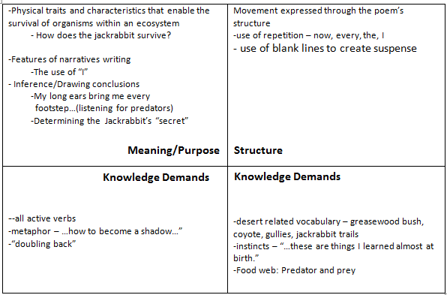

*For more information on the qualitative dimensions of text complexity, visit http://www.achievethecore.org/content/upload/Companion_to_Qualitative_Scale_Features_Explained.pdf

3. Reader and Task Considerations
What will challenge my students most in this text? What supports can I provide?

Most kindergarten students correlate poems with rhyming. This poem does not rhyme. Questions about the author’s purpose around the free structure of this poem will be unfamiliar.

It will require guidance to assist students in determining the central idea using supporting ideas and details. It will be important to highlight key ideas and details as the group collectively determines the central idea. Repeat question stem throughout the reading…How does ___________ help Jackrabbit survive?

- Grade level
What grade does this book best belong in? Kindergarten

All content linked to within this resource was free for use when this resource was published in March 2018. Over time, the organizations that manage that external content may move or remove it or change the permissions. If the content is no longer available, please email info@studentsachieve.net.

