Title/Author: Stellaluna by Janell Cannon
Suggested Time to Spend: 5 Days (At least 20 minutes per day)
Common Core grade-level ELA/Literacy Standards: RL.K. 1, RL.K.3, RL.K.4, RL.K.7; W.K.2, W.K.8, SL.K.1, SL.K.2, SL.K.5, SL.K.6, L.K.4
Lesson Objective:
Students will listen to a beautifully illustrated picture book read aloud and use literacy skills (discussion and listening, reading and writing,), with attention to vocabulary and illustrations, to understand the central message of this picture book.

Teacher Instructions
Before the Lesson
- Read the Big Ideas and Key Understandings and the Synopsis below. Please do not read this to the students. This is a description to help you prepare to teach the book and be clear about what you want your children to take away from the work.
Big Ideas/Key Understandings/Focusing Question:
What does Stellaluna learn about herself and her bird friends when she loses her mother? Stellaluna learns that she can make friends with birds who are different from her, and she learns that she can use her “bat” instincts to help her friends.
What is this story trying to teach us? Even though we have many differences, we can still be friends and learn from one another.
Synopsis
In this story, a baby bat separated from her mother is raised by a mother bird, on the condition that she acts as birds do: sleep at night, don't hang upside down, and eat worms and insects. Though she doesn't like behaving in this way, Stellaluna agrees and tries to prove that she fits in with the birds. One day Stellaluna meets a group of bats and is reunited with her mother, who teaches her how real bats act. Stellaluna tries to show her bird friends how to be bats, but realizes that they are better at just being birds, much as she is better at being a bat. Stellaluna uses her understanding of the birds to recognize when they are in trouble, and relies on her bat strengths to save her friends when they attempt to fly at night. Despite their differences, Stellaluna and the baby birds remain great friends.
- Go to the last page of the lesson and review “What Makes This Read-Aloud Complex.” This was created for you as part of the lesson and will give you guidance about what the lesson writers saw as the sources of complexity or key access points for this book. You will of course evaluate text complexity with your own students in mind, and make adjustments to the lesson pacing and even the suggested activities and questions.
- Read the entire book, adding your own insights to the understandings identified. Also note the stopping points for the text-inspired questions and activities. Hint: you may want to copy the questions, vocabulary words, and activities over onto sticky notes so they can be stuck to the right pages for each day’s questions and vocabulary work.
- Consider pairing this series of lessons on Stellaluna with a text set to increase student knowledge and familiarity with bats. A custom text set can be found here.
Note to teachers of English Language Learners (ELLs): Read Aloud Project Lessons are designed for children who cannot read yet for themselves. They are highly interactive and have many scaffolds built into the brief daily lessons to support reading comprehension. Because of this, they are filled with scaffolds that are appropriate for English Language Learners who, by definition, are learning to read (English). In this Stellaluna example, the text complexity places it in the grade 2–3 band-well above what kindergarten students could read themselves. Sentence structure and vocabulary are qualitatively the most complex features of this text so it offers many opportunities for learning. At the same time, the supports and structures built in make the text accessible to even the youngest students.

This lesson includes features that align to best practices for supporting English Language Learners. Some of the supports you may see built into this, and /or other Read Aloud Project lessons, assist non-native speakers in the following ways:

- These lessons include embedded vocabulary scaffolds that help students acquire new vocabulary in the context of reading. They feature multi-modal ways of learning new words, including prompts for where to use visual representations, the inclusion of student-friendly definitions, built-in opportunities to use newly acquired vocabulary through discussion or activities, and featured academic vocabulary for deeper study.
- These lessons also include embedded scaffolds to help students make meaning of the text itself. It calls out opportunities for paired or small group discussion, includes recommendations for ways in which visuals, videos, and/or graphic organizers could aid in understanding, provides a mix of questions (both factual and inferential) to guide students gradually toward deeper understanding, and offers recommendations for supplementary texts to build background knowledge supporting the content in the anchor text.
- These lessons feature embedded supports to aid students in developing their overall language and communication skills by featuring scaffolds such as sentence frames for discussion as well as written work and writing opportunities (and the inclusion of graphic organizers to scaffold the writing process) that require students to use newly acquired vocabulary and text-based content knowledge.

The Lesson – Questions, Activities, and Tasks

Questions/Activities/Vocabulary/Tasks | Expected Outcome or Response (for each)
FIRST READING:  Pull the students together in a close group or use a document camera so that all students can see the illustrations. Read aloud the entire book with minimal interruptions. Stop to provide word meanings or clarify only when you know the majority of your students are confused about the gist of what is happening in the story.  Puppets:  http://d33y93cfm0wb4z.cloudfront.net/slideshow/pdfs/bat_finger_puppet.pdf This is the pattern for a finger puppet to be used during retells or vocabulary activities. | The goal during the first read is for students to enjoy the book, taking in both the beautiful storytelling and the illustrations. This will give them some context and sense of the whole before they dive into examining parts of the book more closely during later reads.  Students make bat puppets today to use during the story and in subsequent lessons.
SECOND READING:  The goal of this second read is to have students practice selected vocabulary by using Total Physical Response* with body movements, facial expressions and their bat puppets. During this reading, the teacher should elaborate with gestures and expression to build vocabulary concepts.  Create an anchor chart with some or all selected words for students to refer to during subsequent reads and activities.  clutch  p. 2 Clutched . . . “Mother Bat would carry Stellaluna clutched to her breast as she flew out . . .”  Look at the picture under the document camera to show students what Mother Bat is doing. What do you think clutch means? (Have students “clutch” their Stellaluna puppet.)  p. 3 Swooped, dodged, shrieking  swooped  Swooped means to move through the air quickly. (Show students that the owl is swooping out of the sky toward Mother Bat. Model with your hand as the Owl and swoop toward the bat puppet.)  dodge  Dodge means to move out of the way quickly.  (Show students with your hand and puppet how Mother Bat tries to escape by dodging the owl.) Can you dodge the owl with your bat puppet?  shriek  Play video clip from YouTube so students can hear the shriek of bats. http://www.youtube.com/watch?v=7X-6_4WBdZs  clutch  p. 5 …she clutched the thin branch, trembling with cold and fear.  Remember the word clutched means to hold onto something tightly. (Have students clutch their bat.) Why is Stellaluna clutching?  *Turn to your partner and retell what happened in this part of the story. Use your puppet to act out the events and explain in words. Remember the new words we learned: swooped, dodged, shrieking, clutch*  clamber  p. 7 Stellaluna quickly clambered from the nest and hung out of sight below it. What does it mean to “clamber”? Show me with your puppet.  bear it no longer  p. 9 Reread third paragraph: “Finally, though the little bat could bear it no longer. She climbed into the nest, closed her eyes, and opened her mouth. PLOP! In dropped a big green grasshopper.” When the author says, ‘the little bat could bear it no longer,’ it means she couldn’t stand it or take it any longer. What couldn’t she bear?  gracefully  p. 17 Gracefully—model “gracefully” by teacher walking across  the floor. Show not gracefully, also known as clumsy. Then have students show “gracefully” demonstrating walking around in a circle group.  p. 20 Look at the pictures to determine that she is not landing gracefully. She is embarrassed. Why is Stellaluna embarrassed?  anxious  p. 23 “The three anxious birds went home without her.” To be anxious means that you are worried or upset about something. Show on your face what an anxious person might look like. What are the birds anxious about?  peculiar  (Finish reading the page, then go back and read the sentence below.)  On page 27, ‘“Stellaluna’s eyes opened wide. She saw the most peculiar face.” the creature said.’ Peculiar means strange or not usual. Why does Stellaluna think this animal is peculiar or strange?  escape  p. 31 “’You escaped the owl?’ cried Stellaluna.” Escape means to get away from a dangerous place or situation. (Have students put their bat under their legs and make the bat escape.)  survive  p. 31  “You survived?” Survived means to stay alive. Why is Stellaluna surprised that her mother survived?  muse  p. 41 ‘“How can we be so different and feel so much alike?” mused Flitter.’ Muse means to think about something for a long time. What is Flitter musing about?  mystery  “I think this is quite a mystery,” Flap chirped.  A mystery is something that people do not understand or can’t explain because they don’t know enough about it.  Why does the author want you to think about this mystery?  Tomorrow when we read the story again and discuss how Stellaluna and her friends are alike and different, we can help solve this mystery.  *Total Physical Response, also widely known as TPR, is an approach that focuses on teaching language together with physical activities. The main idea behind this approach is that students can more quickly learn languages if they associate a physical act to a word. For example, if a teacher says "wave," students wave their hands in response. Read more: http://www.ehow.com/info_7895677_total-physical-response-activities.html#ixzz2rTvmo5xQ | Students practice clutching.  Stellaluna is trying to clutch or hold onto the twig so she doesn’t fall.  Students retell and act out the scene with their puppets and words.  The owl is swooping down from the sky. Mother Bat is dodging and trying to get away. She is shrieking because she is scared.  Then Stellaluna falls and is clutching the twig so she does not fall from the tree.  Students practice clambering.  Stellaluna can no longer bear being hungry, so she allows the mother bird to feed her a big green grasshopper!  Students practice clumsy and gracefully.  Embarrassed means feeling nervous and uncomfortable and worrying about what people think of you. For example, if you had to sing in front of a lot of people you may feel embarrassed if you messed up.  Stellaluna is embarrassed because she cannot land gracefully on the tree branch, the way the birds can.  They are worried about Stellaluna because she is outside at night all by herself. Since she is their friend, they are worried that something might happen to her, but they have to leave her in order to stay safe themselves.  Stellaluna has been living with birds! She thinks the bat is strange even though she is a bat because she is now used to being around birds!  Students practice acting out escape.  Stellaluna thought that her mother would not survive the owl attack. She thought her mother might be dead.  He is thinking about how different he is than Stellaluna but also how similar they are.  The author wants you to think about the mystery so that you can learn something about the birds and bats. She also wants you to think about the reasons they feel this way about each other.
THIRD READING:  Focus on specific sections of text to understand ---What does Stellaluna learn from the birds?  Begin t-chart focusing on the things that birds do.  What can birds do? What can bats do?  Turn and talk to your partner using the following language frame:  Partner A: Another thing she learns to do like the birds is….  Partner B: Stellaluna also learned to do ……. like the birds.  (Use student responses to fill in the chart.)  Listen to find more things that Stellaluna learns to do like the birds. Also, listen for things that bats do.  (Begin to reread book and use student responses to continue filling in the chart.)  Reread page 2. What does Mother Bat do with Stellaluna every night?  Reread page 3. The author tells us what type of food bats eat. What do they eat?  How does the picture on page 8 help you to understand what is happening in the  story?  Reread page 9. What are some things Stellaluna learns to do after she falls into the birds’ nest?  After reading page 11 ask students, what is one of the bat ways that Stellaluna did not change?  The curious baby birds were wondering why Stellaluna was hanging by her feet. What did those curious birds do?  Reread pages 27-38. How does Stellaluna find out what bats are supposed to do?  (On the right-hand side of the t-chart, you will record things that bats do.)  Students use a language frame to share what bats do:  Partner A: One thing bats can do is_______________.  Partner B: Another thing bats can do is ____________.  How does Stellaluna feel about being a bat now? Listen to this part of the story to find out. Raise your puppet when you hear something in the story that shows how Stellaluna feels. Teacher reads pages 35-37.  Finish reading the story.  What happens to Stellaluna’s bird friends?  How does Stellaluna use her abilities as a bat to rescue them? You might use our new words: swoop, shriek or grasp.  Stellaluna says, “But we’re friends and that’s a fact.”  What does Stellaluna mean? What do you think she learned? | She clutches Stellaluna while searching for food every night.  Bats eat ripe fruit.  Stellaluna is in the birds’ nest. Her mom is lost. There are three other birds in the nest.  Stayed awake all day, slept at night, ate bugs, land on branches gracefully with their feet.  She liked to hang by her feet.  The baby birds hung by their feet to try it out.  Her mother and the other bats tell her and show her how bats act.  Student responses can be…..  Hang upside down, fly at night, eat fruit, can see everything at night  Students hold up their puppets when they hear phrases:  -“I’ll never eat another bug as long as I live,” cheered Stellaluna  as she stuffed herself full.  --“Wait until dark,” Stellaluna said excitedly.  Students use their puppets to act out the final stages of the story when the birds try to fly from the tree with Stellaluna, and cannot see where they are going. They continue showing with their puppets what Stellaluna must do to save her friends.  The friends know that they are different, but are glad that they can do some things together that are the same. She says being friends in a fact because it’s true. They can be friends even though they are different kinds of animals.

FINAL DAY WITH THE BOOK - Culminating Task
- How is Stellaluna the same and different from her bird friends? What do Stellaluna and the birds learn about each other?
- See the sample answer on the last page of this document.
- A version of this task with sentence frames is available for extra support at the end of this document.

Vocabulary
These words merit less time and attention  (They are concrete and easy to explain, or describe events/  processes/ideas/concepts/experiences that are familiar to your students ) | These words merit more time and attention  (They are abstract, have multiple meanings, and/or are a part  of a large family of words with related meanings. These words are likely to describe events, ideas, processes or experiences that most of your student will be unfamiliar with)
Page 2: clutch – to hold tightly  Page 3: swoop – to move quickly down through the air  Page 3: dodge – to move out of the way quickly  Page 31: escaped – getting away from a dangerous situation  Page 39: shrieked – make a very high, loud sound, especially because you are afraid, angry, excited, or in pain | Page 9: bear – tolerate the feelings that you have (hunger)  Page 17: gracefully – moving in a smooth and attractive way  Page 23: anxious – worried about something  Page 27: peculiar – strange or not usual  Page 31: survived-continue to live after an accident or illness  Page 41: muse – to say something in a way that shows you are thinking about it carefully  Page 41: mystery – a situation people do not understand or cannot explain because they don’t know enough about it

Fun Extension Activities for this book and other useful Resources
- This is the pattern for a finger puppet to be used during retells or vocabulary activities.
  - http://d33y93cfm0wb4z.cloudfront.net/slideshow/pdfs/bat_finger_puppet.pdf
- Refer to Bat Notes on pages 42 and 43. Read the Bat Notes to students. Have students identify new information to add to the T-chart.
- This website provides an article and pictures to give more details about bats. Do a read aloud with students. The article provides guiding questions to ask students for each section.
  - http://www.nwf.org/Kids/Ranger-Rick/Animals/Mammals/Fruit-Bats.aspx
- Play the video for students after reading Stellaluna. Ask students what new information we have learned about bats and add it to the T-chart. Note: This is particularly supportive of English Language Learners.
  - http://video.nationalgeographic.com/video/kids/animals-pets-kids/mammals-kids/bat-flying-fox-kids/
- Students can listen to the story being read at a listening center. Note: This is particular supportive of English Language Learners.
  - https://www.schooltube.com/video/003196835a384365822b/

Note to Teacher
- Remind students of parameters of partner talk, as necessary.
- Language Frames can be very supportive for English Language Learners and language impoverished students. If students are not familiar with frames, briefly model using these frames with students and encourage listening skills as well as speaking skills during partner talk. These frames will scaffold student responses by “unpacking” the question and initiating a response.

What Makes This Read-Aloud Complex?
- Quantitative Measure
Go to http://www.lexile.com/ and enter the title of your read-aloud in the Quick Book Search in the upper right of home page. Most texts will have a Lexile measure in this database.

_550 Lexile_
Most of the texts that we read aloud in K-2 should be in the 2-3 or 4-5 band, more complex than the students can read themselves.
2-3 band 420-820L
4-5 band 740-1010L

- Qualitative Features
Consider the four dimensions of text complexity below*. For each dimension, note text-specific examples.
Knowledge Demands
Language
Structure
Meaning/Purpose
*For more information on the qualitative dimensions of text complexity, visit http://www.achievethecore.org/content/upload/Companion_to_Qualitative_Scale_Features_Explained.pdf

Theme: Differences, friendship
Many students may have difficulty identifying the deeper meaning of this story without teacher support: Even though Stellaluna and her bird friends are very different, they are able to appreciate each other use their unique qualities to help one another. They are true friends.
Narrative
The story is chronological. At times, the text switches back and forth from dialogue to narrative.
Sentence structure and vocabulary is sometimes complex.
Oh, how Mother Bat loved her soft tiny baby.
Each night, Mother Bat would carry Stellaluna clutched to her breast as she flew out in search of food.
They hang by their feet and they fly at night and they eat the best food in the world,” Stellaluna explained….

Students are likely to be familiar with bats and birds.
3. Reader and Task Considerations
What will challenge my students most in this text? What supports can I provide?
Vocabulary and sentence structure will be challenging for students, particularly for ELL and language impoverished children. The second read will scaffold this area of complexity and provide teacher explanations, Total Physical Response and visual images for vocabulary. Students may need background on scientific knowledge of bats and birds, which can be provided with photos, videos, and articles, as well as a companion non-fiction text (e.g., BATS by Gail Gibbons).

How will this text help my students build knowledge about the world?
Students will learn some information about bats and birds. This text will also help students learn that we can be friends with people who are different than we are. We can use our own strengths to help others.

4. Grade level
What grade does this book best belong in?
This book would be best used with Kindergarten or early first grade. These students are learning to understand how other people communicate and act that are outside their family unit. The vocabulary included in this read aloud will also be highly beneficial for young students.
Name _________________ Stellaluna Culminating Activity

How is Stellaluna the same as her bird friends? How is she different? What do Stellaluna and the birds learn about each other?

________________________________________________________________________________________________________________________________________________________________________________________________________________________________________________________________________________________________

Name _______________________ Stellaluna Culminating Activity

How is Stellaluna the same as her bird friends? How is she different? What do Stellaluna and the birds learn about each other?

One thing that is the same about the birds and Stellaluna is _____________

_______________________________________________________________________.

One thing that is different is that the birds ______________________________

but Stellaluna _________________________________________________________.

Stellaluna and the birds learned that ____________________________________

_______________________________________________________________________.

Culminating Activity Sample Response (with sentence frames)
One thing that is the same about the birds and Stellaluna is that they both fly________.
One thing that is different is that the birds eat worms____________________________,
but Stellaluna eats fruit____________________________________________________.
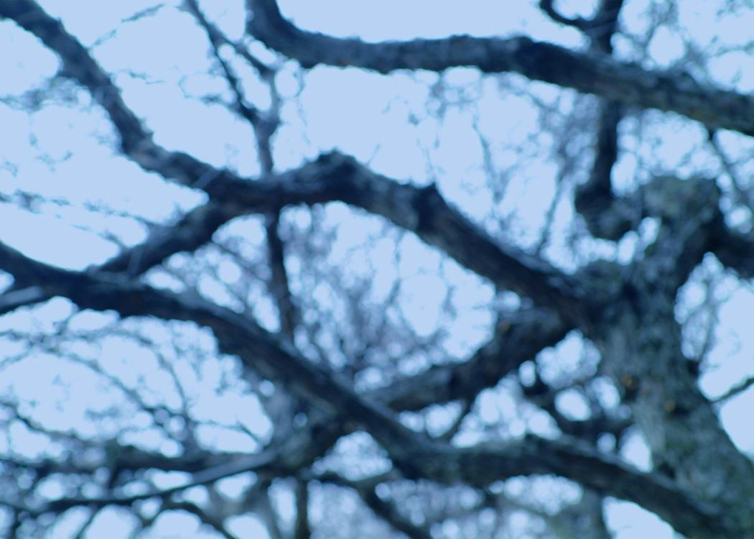
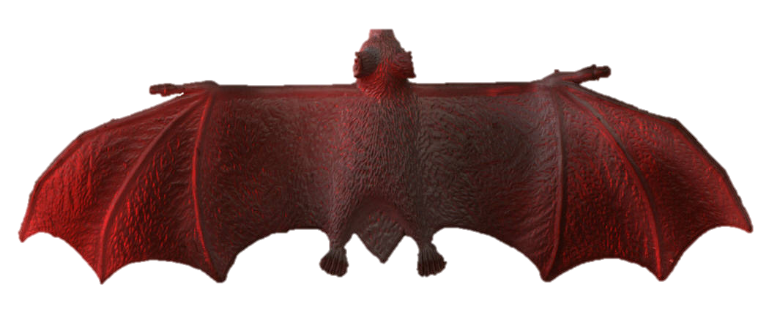
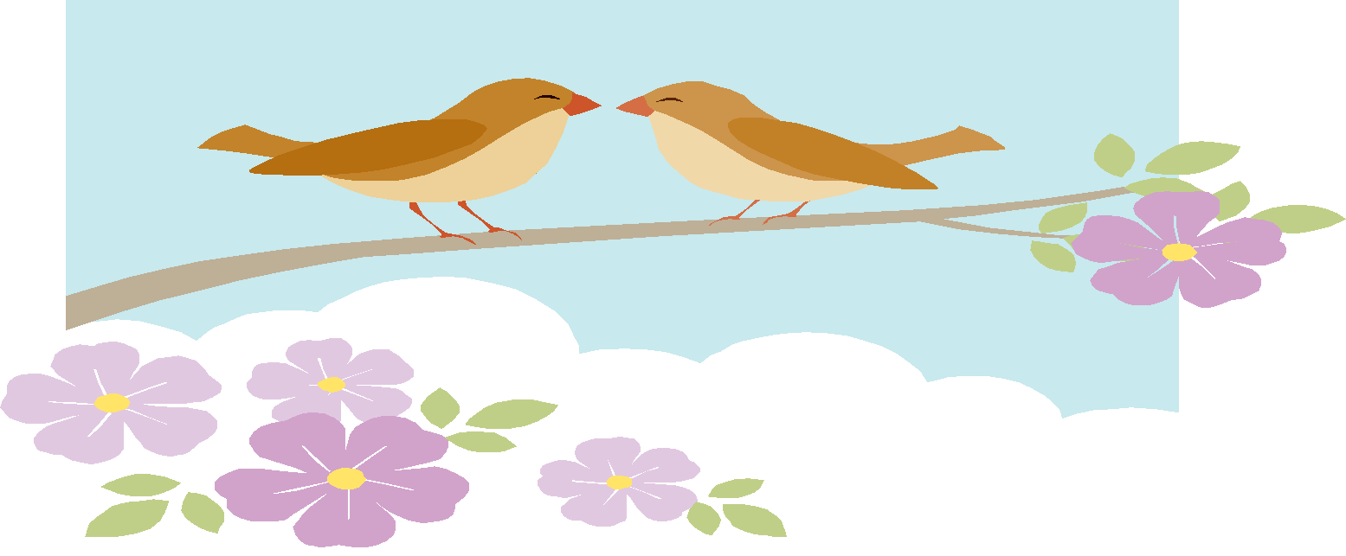
Stellaluna and the birds learned that they can be different and feel so much alike. They are friends.

All content linked to within this resource was free for use when this resource was published in March 2018. Over time, the organizations that manage that external content may move or remove it or change the permissions. If the content is no longer available, please email info@studentsachieve.net.

