Title/Author: The Cloud Book by Tomie dePaola
Suggested Time to Spend: 10 Days (Recommendation: one session per day, at least 20 minutes per day)
Common Core grade-level ELA/Literacy Standards: RI.2.1, RI.2.2, RI.2.3, RI.2.4, RI.2.5, RI.2.6; W.2.8; SL.2.1, SL.2.2
Lesson Objective:
Students will listen to an illustrated informational text read aloud and use literacy skills (reading, writing, discussion, listening, and research) to understand the big idea and use the information for real-world application.

Teacher Instructions
Before the Lesson
- Read the Big Ideas and Key Understandings and the Synopsis below. Please do not read this to the students. This is a description to help you prepare to teach the book and be clear about what you want your children to take away from the work.
Big Ideas/Key Understandings
There are various types of clouds that can be observed. People have used clouds (and their understanding of clouds) to predict upcoming weather.
Focusing Questions
- How can understanding clouds help you understand weather?
- How would you describe the three main kinds of clouds?
- What headings would work for this text? Why?
Synopsis
This informational text is written with beautifully illustrated pictures that capture the details of the many types of clouds. This text focuses on the 10 main types of clouds. dePaola’s informational text explores the types of clouds, the myths about certain shapes, and popular sayings inspired by clouds and the weather.
- Go to the last page of the lesson and review “What Makes This Read-Aloud Complex.” This was created for you as part of the lesson and will give you guidance about what the lesson writers saw as the sources of complexity or key access points for this book. You will of course evaluate text complexity with your own students in mind, and make adjustments to the lesson pacing and even the suggested activities and questions.
- Read the entire book, adding your own insights to the understandings identified. Also note the stopping points for the text-inspired questions and activities. Hint: you may want to copy the questions vocabulary words and activities over onto sticky notes so they can be stuck to the right pages for each day’s questions and vocabulary work. If your version of the book does not have page numbers begin by numbering the first page of text as page 5. This will help ensure that any reference to page numbers in the plan will be clear.
- Consider pairing this series of lessons on The Cloud Book with a text set to increase student knowledge and familiarity with the topic. A custom text set can be found here. Note: This is particularly supportive of ELL students.

Note to teachers of English Language Learners (ELLs): Read Aloud Project Lessons are designed for children who cannot read yet for themselves. They are highly interactive and have many scaffolds built into the brief daily lessons to support reading comprehension. Because of this, they are filled with scaffolds that are appropriate for English Language Learners who, by definition, are developing language and learning to read (English). This read aloud text includes complex features which offer many opportunities for learning, but at the same time includes supports and structures to make the text accessible to even the youngest students.

This lesson includes features that align to best practices for supporting English Language Learners. Some of the supports you may see built into this, and /or other Read Aloud Project lessons, assist non-native speakers in the following ways:

- These lessons include embedded vocabulary scaffolds that help students acquire new vocabulary in the context of reading. They feature multi-modal ways of learning new words, including prompts for where to use visual representations, the inclusion of student-friendly definitions, built-in opportunities to use newly acquired vocabulary through discussion or activities, and featured academic vocabulary for deeper study.
- These lessons also include embedded scaffolds to help students make meaning of the text itself. It calls out opportunities for paired or small group discussion, includes recommendations for ways in which visuals, videos, and/or graphic organizers could aid in understanding, provides a mix of questions (both factual and inferential) to guide students gradually toward deeper understanding, and offers recommendations for supplementary texts to build background knowledge supporting the content in the anchor text.
- These lessons feature embedded supports to aid students in developing their overall language and communication skills by featuring scaffolds such as sentence frames for discussion and written work (more guidance available here) as well as writing opportunities (and the inclusion of graphic organizers to scaffold the writing process). These supports help students develop and use newly acquired vocabulary and text-based content knowledge.

The Lesson – Questions, Activities, and Tasks

Lesson Materials – Questions, Activities, and Tasks
First Reading: The Cloud Book, questions
Second Reading: Reread The Cloud Book, cards, marker
Third Reading: The Cloud Book pages 8-11, Third Reading Materials (Cirrus, Stratus, Cumulus) from secondary text resource
Fourth Reading: The Cloud Book pages 12-27, Fourth Reading Materials – Cloud Chart, Fourth Reading Materials in secondary text resource
Culminating Task: The Cloud Book (for reference), Cloud Chart (for reference), “Bank of Words”

Questions/Activities/Vocabulary/Tasks | Expected Outcome or Response (for each)
FIRST READING:  Read aloud the entire book (or chapter) with minimal interruptions. Stop to provide word meanings or clarify only when you know the majority of your students will be confused.  If possible, display the book on an overhead projector, or document camera, while reading the story. This way, students can look at the illustrations which help to enhance the story.  Questions for Students:  - Prior to reading: What do you know about clouds?  - What is this book about?  - Give an example of what you learned about clouds.  - What type of text is this book? | The goal here is for students to enjoy the book, both writing and pictures, and to experience it as a whole. This will give them some context and sense of completion before they dive into examining the parts of the book more carefully.  - Class discussion. Have students turn and talk with a partner. Stop. Have partners report on what they know about clouds.  - Class discussion. Students give responses individually.  - Class discussion. Students give responses individually.  - This book is an example of informational text. It provides factual information for ten cloud types and popular myths associated with cloud shapes and sayings used to predict/plan/prepare/adapt to possible upcoming weather patterns.
SECOND READING:  Reread entire text, Cards for student headings, marker  The class will participate in naming the headings for each section. These will be placed on the board. The teacher will reread each section and in a whole class discussion the students will select the most appropriate heading for that section. Students will then be given 1-2 headings and will work in their collaborative groups to find evidence from the text to support the heading chosen for that section.  Question for Students:  - What are the three main kinds of clouds?  - What is the main idea of this section? How would you name it? We call that a “heading”; it helps the reader understand what they will read about. What heading would you give for this section to help a reader understand what they will read about?  - What evidence did you find in the text that helped you decide which heading to choose for this section? (Students will work collaboratively in their groups and discuss, using evidence from the text, why this heading was chosen for this section.) | - Discuss. Cirrus-white and feathery-the highest clouds. Cumulus-puffy with flat bottoms-low down in the sky. Stratus-wide blankets of grey-low in the sky.  - In collaborative groups students will orally suggest headings for sections of the text. Example headings include: Pages 5-7 (Introduction), 8-11 (Three Main Clouds), 12-27 (Other Kinds of Clouds), 18 (Fog), 19 (Mountain Names for Clouds), 20-23 (Long Ago Ideas About Clouds), 24-28 (Sayings About Clouds and Weather), 29-31 (The Cloud Story). The teacher will write the headings on cards and place them on the board. The teacher will then reread the section and students (whole class) will choose the appropriate heading for that section. Students will agree on the best heading for that section.  - Assign each group 1-2 headings. Groups work together and find evidence from the text to provide evidence that the chosen heading was the appropriate choice. Once groups have finished collaborating, a representative from each group will discuss their heading and will provide evidence from the text as to why they chose that heading.
THIRD READING:  Read pages 8-11, Materials labeled Third Reading, informational cards can be taken/cut from the Example Cloud Book(secondary text resource). Students will be utilizing texts from The Cloud Book and the secondary text resource Example Cloud Book.  Prior to reading, give table groups 3 cloud pictures and separate information cards from the secondary text resource(these can be cut/utilized from the information found the Example Cloud Book for Cirrus, Stratus, Cumulus Clouds). Ask students to listen for clues that will help them sort their clouds/information correctly.  Have the book projected through a document camera. Read the informational text aloud to students.  Students will sort their clouds (name/pictures, description) and defend their solution. Students can use the text and illustrations from the book for evidence. Students place correct pairs in/on a chart for all students to visualize.  Questions for Students:  - How did the author use text and illustrations to help you sort your cloud cards?  - Using the text, provide one example of how the author described what each of the three main types of clouds “looks like” in the book.  - What Kind of weather is associated with each cloud type?  - How does the author help you understand what clouds are?  - How do you know what a cumulonimbus cloud is?  - Why did the author describe Altostratus and Altocumulus clouds on page 14?  - Is the saying on page 25 correct or incorrect? How could you find out? | - Example: We put this picture with Stratus because like on page 11. The author states that Stratus clouds are low and they look like wide blankets of gray. The illustration shows clouds that look like gray blankets piled up. Our picture and description match.  - On page 9, the author described cirrus clouds as looking like “mares’ tails.” On page 10, the author described cumulus clouds as looking like cauliflowers. On page 11, the author described stratus clouds as looking like wide blankets of gray.  - Students will use evidence from the book-text and illustrations to show evidence.  - On page 6 the author states the clouds are drops of ice or water hanging in the upper atmosphere and the illustration shows the cloud way up in the sky.  - The author tells you that you see them during a thunderstorm. He uses the word “mountains” to describe them and shows a dark mountain of a cloud in the illustration.  - The author describes both to show you how they are the same and different. They are the same in that they can be gray and rain or snow may fall from them. Altostratus look like sheets and Altocumulus are large puffs. The illustrations show the differences in shape and color.  - Student responses will vary. A student may come up with an experiment that could be conducted at school or at home.
FOURTH AND BEYOND:  Reading Focus 12-27, Materials labeled Fourth Reading- Cloud Chart  At table groups give each table 7 cloud types. Students will collaboratively discuss each cloud and the type of weather associated with that cloud. Groups will report and information will be posted for students to visualize. Find this in the materials section labelled Fourth Reading -Cloud Chart; Focus reading on pages 12-17.  Questions for Students:  - What kind of weather is associated with each kind of cloud?  - What do you notice about the names of the other 7 types of clouds (cirrocumulus, cirrostratus, altostratus, altocumulus, nimbostratus, nimbocumulus, and cumulonimbus)? Use the text to support your answer. | - Students will use evidence from the text/ illustrations and cloud cards to show evidence.  - Students will notice that the words cumulus, stratus, and cirrus are combined with other words to form the 7 additional types of clouds. On page 12, the author states, “There are also many other kinds of clouds. They have longer names because they look like cirrus, cumulus, or stratus clouds mixed together in pairs.” Students can work in small groups to compare and contrast the different types of clouds. For example, they can look at a cumulus cloud and compare it to a cirrocumulus cloud while using the text and illustrations as support for their understanding.

Third Reading Materials Students can cut out headings and work collaboratively throughout the read aloud to place the correct headings in the correct spaces.
5-7
8-11
12-17
18
19
20-23
24-28
29-31

Headings- To be cut out or students could cut them out and work to place them in the Table of Contents throughout the read aloud.
Introduction
Three Main Clouds
Other Kinds of Clouds
Long Ago Ideas About Clouds
Fog
Mountain Names for Clouds
Sayings About Clouds and Weather
The Cloud Story

Fourth Reading Materials

This is an example model for classifying the 7 cloud types that would be completed by students in either small groups or whole group.

Cloud Name | Description | Position | Weather
Altostratus | Sheets of gray or blue | Middle of the sky | Rain or snow may fall from them

FINAL DAY WITH THE BOOK - Culminating Task (this can be broken up into multiple days):
- Prompt: The students will create a cloud book that will provide descriptions of the main types of clouds and what each cloud can provide in terms of weather forecasting. Use the “Bank of Words” to assist students with creating this book.
- Criteria of Book:
- What are the main types of clouds?
- Use illustrations and adjectives to describe how each cloud looks.
- Can the weather be forecasted depending on the types of clouds in the sky? What possible weather events can occur when the clouds are present?
- Students should make a cover to represent the contents of their cloud book.
- Optional: Students can create a “Table of Contents” for their cloud books with page numbers and cloud type.

Bank of Words to type for the Cut and Paste/Culminating Task

Directions: Teacher types these words in the same font in random order. Students have to read the words, and then match the three columns of words to the correct cloud type. When they have placed their words on one page for one cloud type, they paste, color and review. Students have their texts in front of them if needed. You could have them make a picture of a person ready for that type of weather somewhere in the picture.
Words for Kinds of Clouds | Words that would describe the cloud types. | Position in the sky
Cirrus | Thin  Mare’s Tail  White  Predicts good weather | High
Stratus | Gray  Looks like fog  “high fogs”  predicts mist/drizzle/snow | Low
Cumulus | Thick and puffy  Flat bottom  Light gray  Looks like a cauliflower  Predicts light to heavy rain | Low

Sky, Cloud and Land Drawing |  | Cirrus
High in the sky |  | White  Thin  Mare’s tail  Predicts good weather
Middle of the sky |  | White  Thin  Mare’s tail  Predicts good weather
Low in the sky |  | White  Thin  Mare’s tail  Predicts good weather
Land with person ready for the weather. | Child draws a person on the land ready for the weather under the sky with the cloud (in cotton or white crayon) above. Add writing if you want so you know the child understands the relationship between the weather, the sky, the position and the description of the weather. | White  Thin  Mare’s tail  Predicts good weather

Vocabulary
These words merit less time and attention  (They are concrete and easy to explain, or describe events/  processes/ideas/concepts/experiences that are familiar to your students) | These words merit more time and attention  (They are abstract, have multiple meanings, and/or are a part  of a large family of words with related meanings. These words are likely to describe events, ideas, processes or experiences that most of your student will be unfamiliar with)
Page 6 – atmosphere – air that surrounds the Earth  Page 9 – mare – a female horse  Page 10 – cauliflower – a vegetable that grows with a white head of flowers  Page 12 – mackerel – a large fish  Page 12 – mouton – sheep  Page 12 – cirrocumulus – small groups of white clouds high in the sky  Page 13 – cirrostratus – thin, white clouds that are high in the sky (look like blankets or sheets)  Page 14 – altostratus – clouds in the middle of the sky that are grey or blue which cause rain or snow  Page 14 – altocumulus – puffy clouds, that are gray or white, which cause drizzle or snow flurries  Page 15 – nimbostratus – heavy, dark clouds that are low in the sky (they cause steady rain or snow)  Page 15 – stratocumulus – low cumulus clouds that look like balls, or rolls, that are dark in color (appear in winter)  Page 15 – cumulonimbus – very tall clouds that appear during a thunderstorm  Page 18 – droplet – a small drop of liquid  Page 27 – lofty ship- a ship with very high sails | Page 8 – cirrus – a thin cloud formed high in the sky  Page 8- cumulus – a thick, puffy cloud with a flat bottom  Page 8 – stratus – a cloud formed low in the sky  Page 11 – drizzle – rain that falls very lightly or as a mist

Extension learning activities for this book and other useful resources
- Day One: The students will conduct an experiment to see if they can create a cloud in a jar. Students will write down observations, analyze what occurred in the jar, and list any questions that they still have about clouds.

- Day Two: The students will conduct an experiment to see if they can create cumulus clouds that will produce rain in a jar. Students will write down observations, analyze what occurred in the jar, and list any questions that they still have about clouds.

- Students can conduct daily cloud observations for their city/town for a week. They can draw pictures of the clouds observed and discuss whether or not they were able to forecast the weather (for example, “We observed cumulus clouds and then it rained in the afternoon.”). Note: This is particularly supportive of English Language Learners.

- Show the video, “Magic School Bus: Wet All Over.” Students can learn more about the water cycle after being introduced to the concepts in this video.

Note to Teacher
- These are examples of the two experiments (official PDF with instructions and student pages is attached with this unit).
Example of a Cloud Book (this can be a foldable made from construction paper. Under each “flap” students can list the following:
Pictures were obtained from: www.windows2universe.org
Cirrus Clouds Second Reading Materials
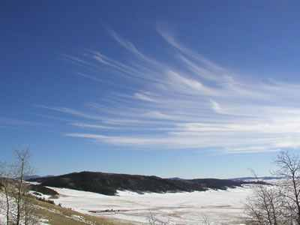
- A thin cloud that is formed high in the sky.
- Also known as “mare’s tales.”
- Predict good weather.

Cirrostratus Clouds Fourth Reading Materials
- A thin, white cloud that is formed high in the sky.
- Look like blankets or sheets.
- Usually predict a rain or snow storm.

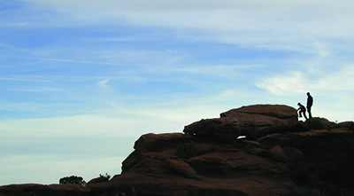
Cirrocumulus Clouds Fourth Reading Materials
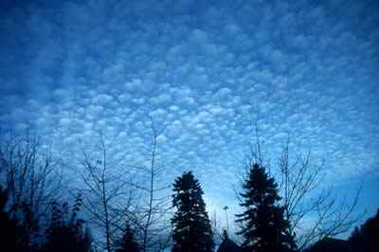
- Small groups of white clouds that are high in the sky.
- Also known as “mackerel sky.”
- Appear in winter time to predict cold weather.
Altostratus Clouds Fourth Reading Materials

- Clouds that are located in the middle of the sky.
- They are usually blue or gray.
- Predict rain or snow.
Altocumulus Clouds Fourth Reading Materials
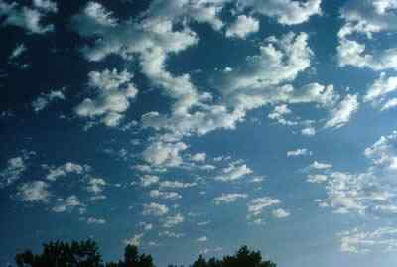
- Puffy clouds that are gray or white.
- Predict drizzle or snow flurries.
Stratus Clouds Second Reading Materials
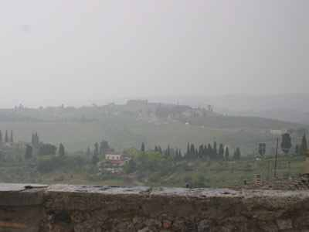
- A cloud that is formed low in the sky.
- Gray
- Can look like fog
- Creates light mist or drizzle.

Stratocumulus Clouds Fourth Reading Materials
- Low cumulus clouds that look like balls or rolls.
- Dark in color
- Appear in winter
- Creates light precipitation.


Nimbostratus Clouds Fourth Reading Materials
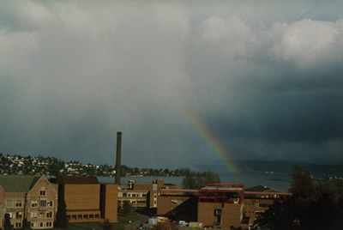
- Heavy clouds that are low in the sky.
- Dark in color
- Creates steady rain or snow.

Cumulus Clouds Second Reading Materials
- A thick, puffy cloud with a flat bottom.
- Can be light gray in color.
- Look like “cauliflower heads.”
- Predict light to heave rain showers.

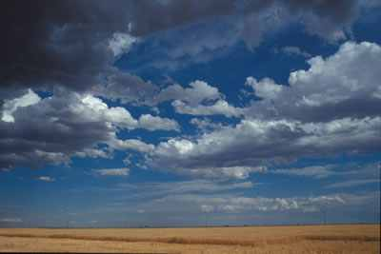

Cumulonimbus Clouds Fourth Reading Materials
- Very large, or tall, clouds.
- Known as “thunderstorm” clouds.
- Predict rain, lightning, tornadoes, hail, and/or snow.

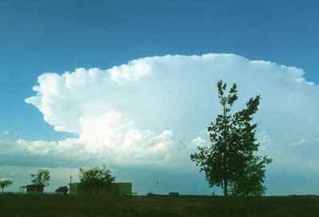

What Makes This Read-Aloud Complex?
- Quantitative Measure
Go to http://www.lexile.com/ and enter the title of your read-aloud in the Quick Book Search in the upper right of home page. Most texts will have a Lexile measure in this database.

Most of the texts that we read aloud in K-2 should be in the 2-3 or 4-5 band, more complex than the students can read themselves.
2-3 band 420-820L
4-5 band 740-1010L

____730 L___

- Qualitative Features
Consider the four dimensions of text complexity below. For each dimension*, note specific examples from the text that make it more or less complex.

- There are 3 major types of clouds.
- There are myths surrounding cloud shapes.
- Informational text with a fun story added
- Illustrations
- Inference
- Text contains facts and fictitious fun

- Figurative (mythical terms)
- Moderately complex
- Phrases take the form of actual weather words

- Contains everyday experiences (weather)
- Discuss type of text
- Help children understand the relationship between weather and preparation for weather.

Meaning/Purpose
Structure

Language
Knowledge Demands

*For more information on the qualitative dimensions of text complexity, visit http://www.achievethecore.org/content/upload/Companion_to_Qualitative_Scale_Features_Explained.pdf

- Reader and Task Considerations
What will challenge my students most in this text? What supports can I provide?
-Weather-specific vocabulary
- Lack of structure; text switches from topic to topic

How will this text help my students build knowledge about the world?
-Introduces/elaborates on weather terms and concepts
-Illustrations depict the differences in cloud types
-Students will be building an understanding of the relationship between the weather, the cloud types, and the preparation for the weather.

- Grade level
What grade does this book best belong in? 2nd Grade

All content linked to within this resource was free for use when this resource was published in March 2018. Over time, the organizations that manage that external content may move or remove it or change the permissions. If the content is no longer available, please email info@studentsachieve.net.

